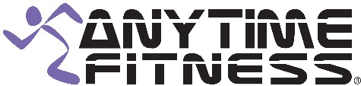 CLASS SCHEDULE
TIME | MONDAY | TUESDAY | WEDNESDAY | THURSDAY | FRIDAY
9:00 AM |  |  | ZUMBA  Nancy Taylor
10:00 AM | GET YOUR STRETCH ON  Leah Marino | BEACH BODY BOOTCAMP  Leah Marino | YOGA  Shannon Liebel | BODY SCULPT  Leah Marino | GET YOUR STRETCH ON  Leah Marino

CLASS DESCRIPTIONS
Zumba: Latin and international music with a fun and effective workout system. Are you ready to dance?
Get Your Stretch On: Warm-up followed by a deep stretch.
Beach Body Bootcamp: Meet at the club and go to Nevada Beach for a great workout on the beach.
Body Sculpt: Combination of spin, step, bosu, and weights.
Yoga: Vinyasa Yoga.

