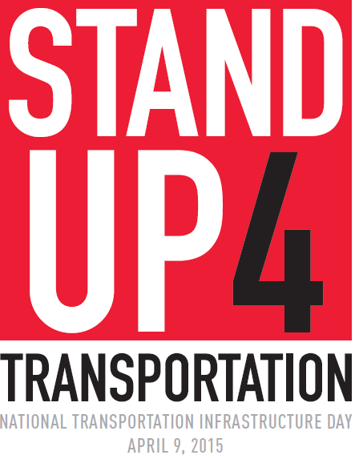
Save the Date!
Please join the Metropolitan Transit Authority of Harris County, elected officials, and community leaders on April 9, 2015 as we collectively call attention to the state of our transportation infrastructure in this country.

Stand Up 4 Transportation Day will be a local day for national education and outreach to the public and our elected officials. Our goal is to raise awareness for the nation’s long-term transportation infrastructure funding plight.

Help send a message to Congress that the expansion, maintenance, and upkeep of our public transportation systems, highways, roads, and bridges need to be dealt with now and we need long-term investment in our aging infrastructure. Join us and together we will make our voices heard!

What: Press event making the case for transportation infrastructure investment

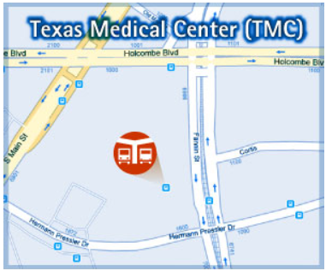
When: Thursday, April 9, 2015
6-7 a.m.

Where: METRO’s Texas Medical Center Transit Center, 6910 Fannin Street at Pressler Drive

Parking: UT Health – University Center Tower garage, 7000 Fannin, directly across Pressler Drive from the transit center

Contact: Russ Frank: 713-739-4808 russ.frank@ridemetro.org

