Kaffe Fassett Event

October 17-19, 2016

Nearby Hotels

Hilton East
7600 E Broadway Blvd
Tucson, AZ 85710
1-520-721-5600
http://www3.hilton.com/en/hotels/arizona/hilton-tucson-east-TUSHEHF/index.html

Radisson Suites Tucson
6555 E Speedway Blvd, Tucson, AZ 85710
Phone:(520) 721-7100
https://www.radisson.com/tucson-hotel-az-85710/aztucsrd

Comfort Suites at Sabino Canyon
7007 E Tanque Verde Rd, Tucson, AZ 85715
Phone:(520) 298-2300
https://www.choicehotels.com/arizona/tucson/comfort-suites-hotels/az023

Need a list of local restaurants or points of interest? We’ll be happy to provide a list of some of our favorites when you arrive!

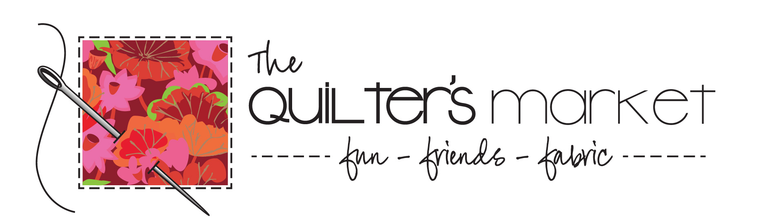
7601 E Speedway
Tucson, AZ 85710
520-747-8458
www.thequiltersmarket.com

