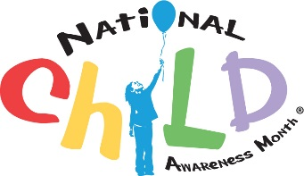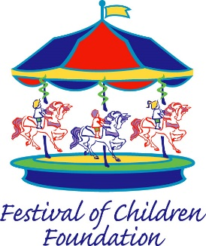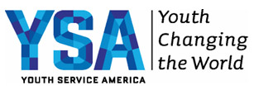

FOR IMMEDIATE RELEASE

New Jersey’s Sabina London, 17, Selected to Serve as a National Child Awareness Month Youth Ambassador
London to receive funding, training to lead large-scale service initiative to create positive change in the lives of New Jersey children

Washington, D.C. (June 30, 2015) –YSA (Youth Service America) and Festival of Children Foundation announce that Sabina London of New Jersey will serve as a National Child Awareness Month Youth Ambassador. As one of 51 Youth Ambassadors selected from a nationwide pool, Sabina will receive funding and training to continue expanding Girls Science Interactive, an organization that provides free STEM summer camps for elementary and middle school girls to spark their interest in science.

Sabina’s work begins in September—National Child Awareness Month— when she travels to Washington, D.C., for leadership training and meetings with members of the state’s congressional delegation. She then returns home to launch a campaign to recruit and train high school students in New Jersey and other states to lead Girls Science Interactive summer camps in their communities. The goal of the camps will be to show young girls that science can be fun and exciting by performing fun hands on experiments to explore areas, such as energy and matter, global warming and renewable energy, astronomy, chemistry, and neuroscience. Since boys are three times more likely to pursue STEM careers than girls, Sabina is focusing on encouraging girls to pursue scientific knowledge at a young age.

Sabina was selected through a competitive application process, and chosen based on the quality of her project proposal and its potential to create substantive, large-scale change on behalf of young people in New Jersey.

Now in its eighth year, National Child Awareness Month is a program spearheaded by Festival of Children Foundation to raise awareness about issues affecting children and encourage the nation's youth to take action.

The 51 Youth Ambassadors will work in their communities, and form a collective network to raise awareness around issues important to young people. Youth Ambassadors receive a national-level platform for their cause; a $1,000 grant to develop a service project his or her home state; ongoing training and project guidance; and networking opportunities with other Youth Ambassadors across the country.

“These teens and young adults are the future of philanthropy. They understand the importance of making a difference and giving back. Festival of Children Foundation’s collaboration with YSA allows us to give these kids the tools to create a powerful youth network that will create lasting change across the country,” said Sandy Segerstrom Daniels, founder and executive director of Festival of Children Foundation.

###
Sabina London is a senior at Northern Valley Regional High School at Demarest who has been passionate about science from a young age. She enjoys spending time in a research lab working on immunology research for which she received national recognition. Sabina founded Girls Science Interactive during her sophomore year with the goal of getting elementary and middle school girls interested in STEM by doing fun, hands-on experiments. In 2015, Girls Science Interactive was awarded several grants to expand into more locations, especially in low-income areas. In two years, the organization grew to 6 free summer camps in New Jersey and Pennsylvania with more camps being planned in New York and Kentucky. In 2015, Sabina was named a Distinguished Finalist in The Prudential Spirit of Community program and was presented with a New Jersey General Assembly Resolution for her outstanding commitment to community service. In school, Sabina is leading Hand in Hand Club as Co-President, which organizes after-school activities for kids with disabilities and enjoys playing tennis. She is also a science blogger for Curious Young Writers (http://www.curiousyoungwriters.org). In the future, Sabina hopes to become a doctor, possibly a pediatric cardiologist or oncologist, and a researcher.

