Bags, Bags and More Bags!
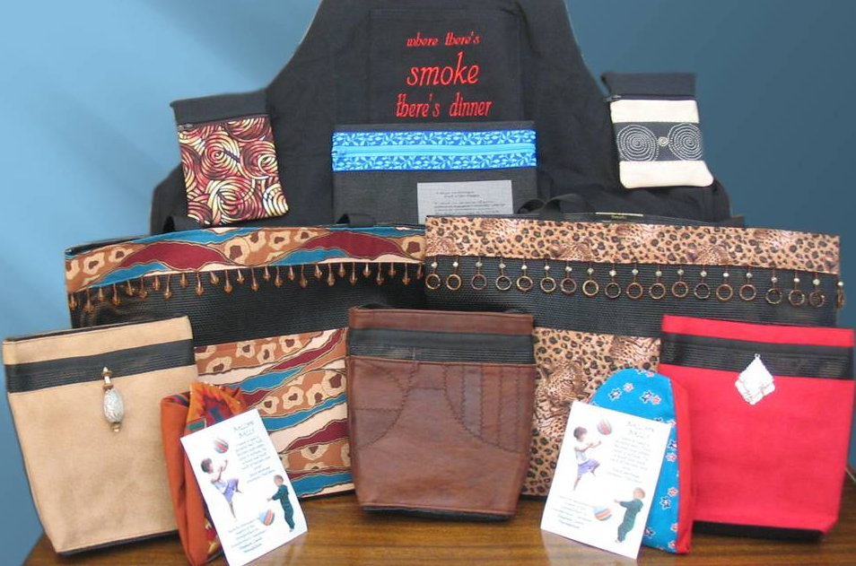We offer a range of bags including tote bags, shoulder bags, minibags, zippy bags, toonie bags, balloon balls, bibs, casserole totes, and aprons. Prices from $2 - $45.

Made by Manitoba volunteers for the
Grandmothers to Grandmothers Campaign
Proceeds are in support of the Stephen Lewis Foundation which cares for the children in Sub-Saharan Africa who have been orphaned by the AIDS pandemic and the courageous grandmothers who are raising them.

To learn more, contact Laurel at (204) 475-7290 or lgarvie@shaw.ca

