News Release
For Immediate Release
Monday, August 10, 2015

Construction Industry Honors Dr. Roger Liska
ABC Kirby Award presented to Clemson CSM Dept. Chair

Contact: Doug Carlson (704) 367-1331

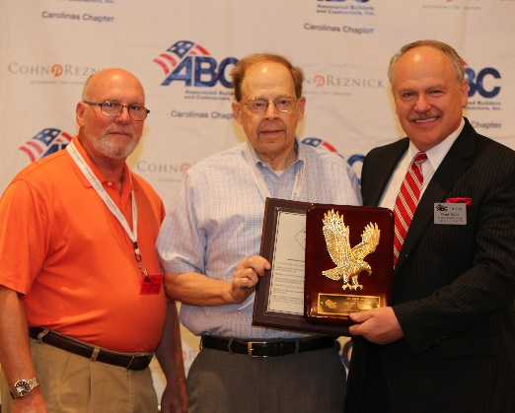
Charlotte, NC — The Associated Builders and Contractors of the Carolinas (ABC) recognized a leader in the industry, Dr. Roger Liska, Clemson University with the industry's most prestigious award, the ABC Kirby Award. Dr. Liska was honored by the ABC Board of Directors at the Carolinas Construction Conference in Charleston, SC. Dr. Liska is the Department Chair for Clemson University School of Construction Science Management.

"We are proud to recognize Dr. Liska for his years of supporting the industry," said Doug Carlson, ABC President & CEO. "Education, training and getting young people interested in our industry have been a passion for his entire career. Dr. Liska is Mr. Construction in our industry."

The ABC Kirby Award is named for Tom Kirby, retired from Austin Industrial, a key founding ABC member. The Kirby Award Resolution States:

The Associated Builders and Contractors of the Carolinas Hereby Resolves:

Whereas, Dr. Roger Liska for his many years of service and dedication to the construction industry and
Whereas, he has held the industry and ABC to a high standard of expertise; and
Whereas, he has promoted the core principles of ABC, the Merit Shop Philosophy and the pursuit of Free Enterprise; and
Whereas, he has given not only of his time, energy and resources, but of his heart; and
Whereas, Dr. Roger Liska has upheld the vision set forth by Tom Kirby for whom this award is named;

Now therefore, be it resolved that the ABC of the Carolinas Board of Directors commend Dr. Roger Liska with the ABC Kirby Award for his outstanding service and commitment, this the 7th of August, 2015.

# # #

Editors Note: Associated Builders and Contractors of the Carolinas represent the merit construction contractors and related firms in the Carolinas as a chapter of ABC, a national association representing more than 23,000 members. For more news and information visit www.abccarolinas.org.

