In Memorium
Galina Prozumenschikova
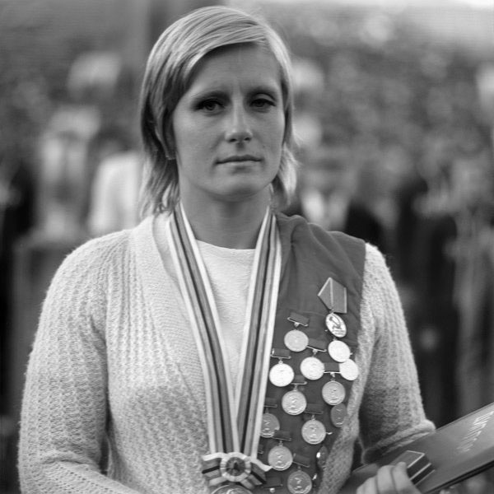
(November 26, 1948- July 19, 2015)

From Russia comes the sad news that Galina Prozumenschikova has passed away at the age of 66. In Olympic pool of Tokyo-1964, she was a 15-years-old blonde Mermaid from Sebastopol who surprised the world by winning the final of 200 m in breast. She thus became the first Olympic swimming gold medalist for the Soviet Union at the Olympic Games.

Galina Prozumenshikova, was not the only European gold medal winner at the 1964 Olympics in Tokyo but 8 years later at Munich, with a three year old son, she was still a medalist. At Mexico City, in between her medals at Tokyo and Munich, an appendectomy a month before the meet and the altitude took its toll as Galina collapsed after the 200 (3rd) and lost the 100 by .001 to Bjedov of Yugoslavia (2nd) and Sharon Wickman of the USA (1st).

After the end of her prominent sporting career, she graduated from Moscow’University and taught at the Swim school of Soviet Army for children for many years.

Prozumenschikova was inducted into the International Swimming Hall of Fame in 1977 and
in 2013, she was recognized as one of the "100 Greatest Swimmers in History" in a book by swim journalist John Lohn.

