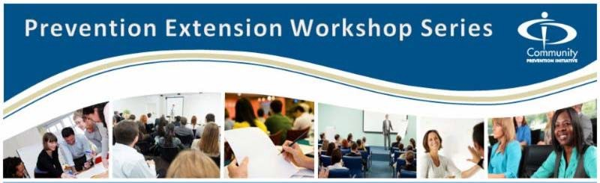CPI Prevention Extension No-Cost Training
Brief Intervention for Substance Using Adolescents – March 22, 2016
Facilitated by: Ira Sachnoff
When:  Tuesday, March 22, 2016  9:00 AM - 3:30 PM  Where:  Santa Clara County Office of Education  1290 Ridder park Drive MC 221  San Jose, CA 95131-2304  Driving Directions  Please Register Online to ensure your participation.  Space is limited!  Continued Education Hours:  6 Hours of Continuing Education Credit available for  BRN and AOD Counselors.  C.E. Hours are offered by CARS for $25.00.  Must be paid in advance during the online registration process.  No payment will be accepted onsite.  CARS is an approved provider for:  CAADAC # 4N-08-923-0603  CA Board of Registered Nurses # 16303  Questions? Contact Us!  Registration Information: Lynn Esposti  lesposti@cars-rp.org  Santa Clara Information: Myrna Zendejas  myrna_zendejas@sccoe.org  Center for Applied Research Solutions  www.ca-cpi.org or (707) 568-3800 | You are invited to attend the Community Prevention Initiative (CPI) Prevention Extension No Cost Workshop, "Brief Intervention for Substance Using Adolescents.”  Training Description:  This training is to build skills of counselors working with adolescents. BI is a short-term counseling intervention that consists of 2 to 4 sessions aimed at adolescents who use alcohol and/or other drugs. This approach uses motivational interviewing, cognitive behavior therapy and the stages of change model to meet the needs of adolescents.  Learning Objectives:  - Examining the counselor’s attitudes and relationship with teens  - Learning to teach adolescents how to take a more active and reflective role in decisions about their own behavior.  - Identifying strategies that would support an adolescent driven plan to make decisions they see as beneficial  - Increasing knowledge about drug and alcohol use among teens  - Utilizing Motivation Interviewing to empower rather than enforce  Target Audience:  School Administrators, Educators, Staff, Counselors and Nurses  Please click on the link below to register.  We look forward to seeing you at the workshop in Santa Clara County !  Sincerely, The CARS Team  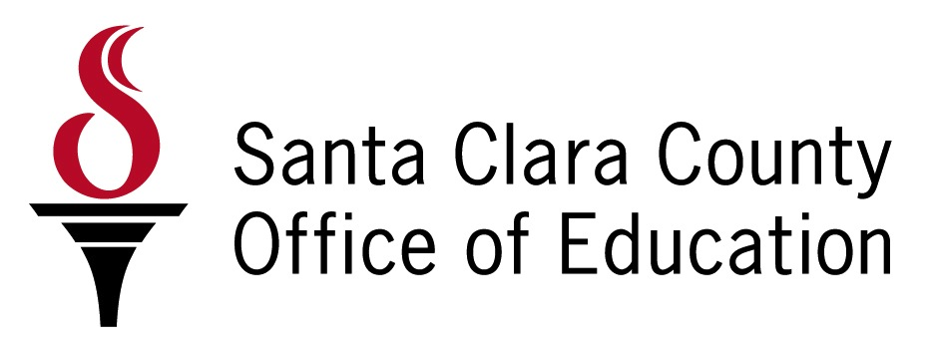
CPI is funded through the California Department of Health Care Services, Substance Use Disorder Prevention, Treatment & Recovery Services Division (DHCS) with training and technical assistance (TTA) administered through the Center for Applied Research Solutions (CARS). The TTA project is intended to serve California agencies and organizations involved in community-based prevention. CPI is able to provide no-cost TTA support for planning and prevention services that include a broad community perspective.

