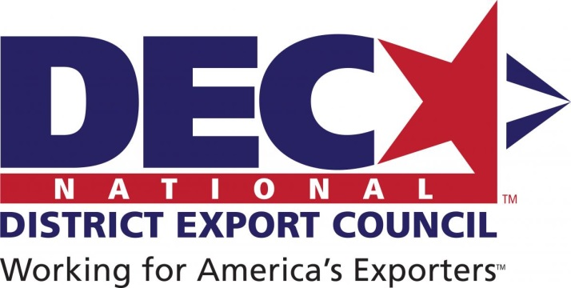

February 1, 2016

RE: Houston District Export Councils Scholarship

Dear Colleagues,

The Houston District Export Council is pleased to announce a competition for two scholarships of $3,000/year for students in the fields of international trade and business, exports, international transportation and logistics, for the 2016-2017 school year.

Applicants must complete the application form, along with the required transcripts, statement of interest, and letters of recommendation.

**Please note: all applicants must hold United States citizenship.**

The District Export Councils contribute leadership and international trade expertise to complement the U.S. Commercial Service’s export promotion efforts through counselling businesses on the exporting process and conducting trade education and community outreach. The 56 District Export Councils (DECs) nationwide are organizations compromised of leaders from their local business community.

The DEC Members are appointed by the Secretary of Commerce. These international trade professionals use their knowledge and international business experience to act as consultants to small and medium sized businesses who want to export their products into markets outside of the United States.

For more than 30 years, DEC’s have served the United States by assisting companies in their local communities export, thus promoting our countries economic growth and creating new and higher-paying jobs for their communities.

Please disseminate this announcement widely in your schools to students majoring in international business and related fields.

Sincerely,



H. Richard Sindelar III