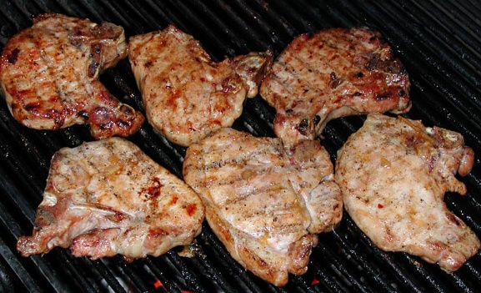

Grilled Pork Chops:

I find the key to making a proper pork chop starts with the brine.

Ingredients
For the brine:
3 cups cold water, divided
3 tablespoons coarse kosher salt (or 2 1/2 tablespoons table salt)
Optional flavorings: 2 smashed garlic cloves, 1/2 teaspoon black peppercorns, 1 bay leaf
"I only used the peppercorns"

For the pork chops:
2 to 4 pork chops - center cut, bone-on, 1-inch to 1-1/4-inch thick
Olive oil
Salt
Pepper
"I prefer the thicker cut"
- Bring 1 cup of the water to a boil, add the salt and optional flavorings, and stir to dissolve the salt. Add 2 more cups of cold water to bring the temperature of the brine down to room temperature. Place the pork chops in a shallow dish and pour the brine over top. The brine should cover the chops - if not, add additional water and salt (1 cup water to 1 tablespoon salt) until the chops are submerged. Cover the dish and refrigerate for 30 minutes or up to 4 hours. "I had them in the brine for 3 hours do to time"
- Preheat your grill to 550-600 degrees. Make sure you have an indirect area to use as well for grilling.
- While the grill heats, prepare the pork chops. Remove the chops from the brine and pat dry with paper towels. Rub both sides with olive oil, then sprinkle with salt and pepper. Set the chops aside to warm while the grill finishes heating up.
- Place the chops directly over the hottest part of your grill, 1-2 minutes per side to sear. After you have seared each side place them quarter turned (for grill mark appearance only) on the indirect portion of your grill which should be about 225-250 degrees. Let grill on each side 5-6 minutes. Chops should register 150-155 degrees, remove from heat and let rest covered for 8-10 minutes. *NOTE* If chops are not up to temp, continue cooking 1 minute per 10 degrees under 150 degrees.

