PUBLIC COMMent DOCUMENT: Virginia’s section 1115 waiver application

An Innovation Waiver Application Public Comment Document for Medicaid Managed Long-Term Services and Supports (MLTSS), Delivery System Reform Incentive Payment (DSRIP), and transition of authority for existing HCBS Waivers: Alzheimer’s, Technology Assisted, and Elderly and Disabled with Consumer Direction

Virginia Department of Medical Assistance Services
Notice of Public Comment Period

Under 42 CFR Part 431 and the final rule under PART 431 in the February 27, 2012 issue of the Federal Register, 77 FR 11678-11700, notice is hereby given that the Department of Medical Assistance Services (DMAS) is soliciting public comment on the §1115 waiver application that will be submitted to the Centers for Medicare and Medicaid Services (CMS). This submission and desired approval will authorize implementation of the MLTSS demonstration, DSRIP demonstration, and transition administrative authority of three existing §1915(c) Home and Community Based Services Waivers into this §1115 waiver. The proposed migration of §1915(c) waiver authority will alter neither eligibility nor services under these three waivers. The §1915(c) waivers included are the Alzheimer’s Assisted Living Waiver (Alzh), Elderly or Disabled with Consumer Direction (EDCD) Waiver and, Technology Assisted Waiver (Tech). If approved, the demonstration will operate January 2017 through December 2022. This notice serves to open the 30 day public comment period, which begins on December 4, 2015, and closes January 6, 2015 at 4:30 pm eastern time.
Instructions for Written Public Comment Submission:
Mail Submission– written comments shall be addressed to Seon Rockwell, Department of Medical Assistance Services, 600 East Broad Street, Suite 1300 Richmond, VA 23219

Electronic Submission – for ease in compilation of comments, all electronic submissions must be a Microsoft Word document, submitted as an email attachment to: 1115waiver@dmas.virginia.gov

Executive Summary
The Department of Medical Assistance Services (DMAS) is submitting an §1115 waiver demonstration application seeking authority to implement two strategic initiatives: (1) Medicaid Managed Long Term Services and Supports (MLTSS) and (2) the Delivery System Reform Incentive Payment (DSRIP) program. Alignment of MLTSS and DSRIP creates a powerful opportunity to strengthen and integrate Virginia Medicaid’s community delivery structure and accelerate payment reforms toward value-based payments.
This comprehensive innovation waiver gives the Centers for Medicare and Medicaid Services (CMS) the opportunity to invest in a DSRIP program that will accelerate transformation, and how care is delivered and paid for in Virginia’s Medicaid system. Through this application, DMAS seeks to ensure that high-value care is the norm and even the most medically complex enrollees with significant behavioral, physical, sensory, and developmental disabilities are supported to live safely and thrive in the community.
DMAS believes in the spirit of innovation and has drafted a proposal that will move the Virginia Medicaid system towards one that incents high quality and high value health care through the advancement of value based purchasing models. If approved, DMAS will invest in the Medicaid provider infrastructure to facilitate the transition to new Medicaid payment strategies and models of care. DMAS recognizes that the Medicaid spending trajectory must change and the best opportunity to accomplish this is through delivery system transformation. To that end, the Department has committed to: “Think Big, Start Focused, and Scale Fast.”
DMAS is confident in this approach and expects CMS partners to appreciate the thoughtful proposal that initially focuses on the portion of the Medicaid population that is the program’s most significant cost driver and then expands to include a broader array of affiliate Medicaid providers. The waiver application focuses on high-touch quality care that results in the development of value based payment methodologies used to sustain the model of care delivery.
- MLTSS: MLTSS will build on the successes of Virginia’s Medicare-Medicaid enrollee demonstration - Commonwealth Coordinated Care. Virginia seeks to strengthen this model, include additional populations, and operate it statewide. Virginia seeks authority to mandate the enrollment of eligible individuals into selected managed care plans. These plans will be competitively selected to ensure access to services and high-quality care.
The populations enrolled and services included in three home and community-based service (HCBS) waivers will be included in the MLTSS program. DMAS seeks to streamline administration of multiple waiver authorities by transitioning the administrative authority of these §1915(c) HCBS waivers. The proposed migration of waiver authority will alter neither eligibility nor services under the included HCBS waivers: Alzheimer’s Assisted Living Waiver (Alzh), Elderly or Disabled with Consumer Direction (EDCD) and, Technology Assisted Waiver (Tech).
- DSRIP: DSRIP will provide funding to support broad provider readiness for value based payment and optimally serve Medicaid’s most complex enrollees through strengthening and better connecting the provider community. DSRIP includes support for the establishment of groups of high-performing providers known as Virginia Integration Partners (VIPs). VIPs will share integrated care, data, processes, and communication. Initially, this will enable the Medicaid program to better offer high-touch, person centered care for its highest utilizers and highest-risk enrollees. These partnerships will include medical, behavioral health, and long-term services and support (LTSS) providers, and also include care navigation and supports. Health systems focused on addressing enrollees’ complex needs will coordinate the VIPs. Funds to support the establishment of VIPs and initial processes will be obtained through achievement of process and outcome measures. VIPs will achieve ongoing sustainability through transition to alternative payment models. In demonstration year 3, DSRIP will launch and support the transition of additional providers, known as Affiliate Providers, to alternative payment models for individuals who are not already receiving care through a VIP. Alternative payment models will be developed in collaboration with contracted health plans.
In 5 years, Virginia envisions a Medicaid delivery system where high-value care is the norm, and even the most medically complex enrollees with significant behavioral, physical, sensory, and developmental disabilities will be supported to live safely and thrive in the community.

Program Description
Virginia is accelerating transformation of its Medicaid delivery system to ensure that high-value care is the norm and even the most medically complex enrollees with significant behavioral, physical, sensory, and developmental disabilities are supported to live safely and thrive in the community. To begin this process, the Virginia Department of Medical Assistance Services (DMAS) is seeking approval of a demonstration project under §1115 of the Social Security Act (Act) to implement two strategic initiatives. Alignment of the following initiatives creates a powerful opportunity to strengthen and integrate Virginia Medicaid’s community delivery structure and accelerate a shift toward value-based payment.
- Medicaid Managed Long Term Services and Supports (MLTSS); and,
- Delivery System Reform Incentive Payment (DSRIP).
As part of the MLTSS initiative, DMAS seeks to streamline authority for three existing §1915(c) Home and Community Based Services Waivers. The proposed migration of waiver authority will alter neither eligibility nor services under these three waivers. The waivers included are the Alzheimer’s Assisted Living Waiver (Alzh), Elderly or Disabled with Consumer Direction (EDCD) and, Technology Assisted Waiver (Tech). Transitioning the authority for these §1915(c) wavers is administrative; this application predominantly focuses on the MLTSS and DSRIP initiatives. The specifics of the §1915(c) authority migrating to §1115 authority will only be referenced in select, applicable sections of this waiver application.
- MLTSS: MLTSS will leverage the successes of Virginia’s Medicare-Medicaid enrollee demonstration-Commonwealth Coordinated Care. Virginia seeks to strengthen this model, expand it to additional populations, and operate it statewide. Virginia seeks authority to mandate the enrollment of eligible individuals into selected managed care plans. These plans will be competitively selected to ensure access and high-quality care.
The populations enrolled and services included in three home and community-based service (HCBS) waivers will be included in the MLTSS program. DMAS seeks to streamline administration of multiple waiver authorities by transitioning the administrative authority of these §1915(c) HCBS waivers. The proposed migration of waiver authority will alter neither eligibility nor services under the included HCBS waivers.
- DSRIP: DSRIP will provide funding to support provider readiness for value based payment and optimally serve Medicaid’s most complex enrollees through strengthening and better connecting the provider community. DSRIP includes support for the establishment of groups of high-performing providers known as Virginia Integration Partners (VIPs). VIPs will share integrated care, data, processes, and communication. This will enable the Medicaid program to better offer high-touch, person centered care for its highest utilizers and highest-risk enrollees. These partnerships will include medical, behavioral health, and long-term services and support (LTSS) providers, and also include care navigation and supports. Health systems focused on addressing enrollees’ complex needs will coordinate the VIPs. Funds to support the establishment of VIPs and initial processes will be obtained through achievement of outcome measures. VIPs will achieve ongoing sustainability through transition to alternative payment models. In demonstration year 3, DSRIP will launch and support the transition of additional providers, known as Affiliate Providers, to alternative payment models for individuals who are not already receiving care through a VIP. Alternative payment models will be developed in collaboration with contracted health plans.

Rationale for the §1115 Demonstration Waiver

Background
The initial concept paper, posted September 11 – October 19, 2015 explains the background and motivations for the pursuit of this Waiver. Additionally, the paper addresses the current limitations in infrastructure and reimbursement strategy. For detailed information regarding the Medicaid populations and focus areas that will be supported through this §1115 waiver application, please view the document: Accelerating Delivery System Transformation in the Virginia Medicaid Program.

Managed Long Term Services and Supports (MLTSS) and the need for operational authority
The 2013 Virginia Acts of Assembly directed DMAS to work toward the inclusion of all remaining Medicaid populations and services, including long-term care and home- and community-based waiver services into cost-effective, managed and coordinated delivery systems.” (Item 307.RRRR.4. - http://lis.virginia.gov/131/bud/hb1500chap.pdf). The 2015 Virginia Acts of Assembly, (Item 301.TTT) again directed DMAS to further principles of care management to all geographic areas, populations, and services under programs administered by the Department. Building off of the successes of the CCC demonstration, DMAS is seeking authority through this §1115 waiver to meet the stated objectives of the Virginia legislature by creating a mandatory managed care program, through the selection of Managed Care plans committed to being certified as a Dual Eligible Special Needs Plan (D-SNP) in Virginia.
Throughout this application, MLTSS refers to the delivery of long-term services and supports, including both HCBS and institutional-based services, through capitated Medicaid managed care plans. MLTSS programs provide an opportunity to create a seamless, integrated health services delivery program. Some of the goals of MLTSS include:
- Improved quality of life, satisfaction, and health outcomes for individuals who are enrolled;
- A seamless, one-stop system of services and supports;
- Service coordination that provides assistance in navigating the service environment, assuring timely and effective transfer of information, and tracking referrals and transitions to identify and overcome barriers;
- Care coordination for individuals with complex needs that integrates the medical and social models of care, ensures individual choice and rights, and includes individuals and family members in decision making using a person-centered model;
- Support for seamless transitions between service/treatment settings;
- Facilitation of communication between providers to improve the quality and cost effectiveness of care;
- Arranging services and supports to maximize opportunities for community living; and,
- System-wide quality improvement and monitoring.

Delivery System Reform Incentive Payment (DSRIP) and the need for infrastructure
Over the past fifteen years, the Commonwealth of Virginia has been committed to a vision of community transformation. Together, with federal, state, and community partners, the Commonwealth has invested a significant amount of time and effort into shifting the cultural paradigm from institutional living to One Community, where all individuals, regardless of ability, disability, or age, can live full lives. DSRIP will facilitate a final push to allow Virginia to migrate away from a system where quality and value are not incented, portions of member care remain fragmented, and coordination is insufficient across the health, behavioral health, substance use, LTSS, and other community support providers. Subsequently, Virginia will capitalize on the opportunity that DSRIP will afford the Commonwealth in order to create culture change.
Virginia anticipates that implementation of MLTSS will move Virginia closer to more streamlined service delivery and higher quality of care for individuals with complex needs. However, a subset of the Virginia Medicaid population has needs so extensive that they will be better served by the MLTSS plans working with a partnership of providers that are fully integrated and share a financial incentive to provide optimal person centered care. DSRIP will support the development of these provider partnerships and the transition to payment models that incent the right care.
Additionally, through the Virginia State Innovation Model (SIM) planning grant, the Commonwealth spent time evaluating the appropriateness and applicability of a DSRIP demonstration. Stakeholders devoted hundreds of hours to identify possible reforms to be included in a SIM round III application, however, the Commonwealth decided that it was not responsible to anticipate further funding through that avenue. Therefore, Virginia determined that there was a significant opportunity to bolster the Medicaid delivery system through pursuit of a DSRIP waiver.
Virginia determined that the greatest opportunity to truly bring about positive change would be realized by leveraging the work of the SIM grant and supporting Virginia’s efforts to develop a system of care and payment model that optimally meets the needs of individuals, even those with the most complex needs.

The Case for a Unified Waiver Approach
Virginia is applying for a §1115 Waiver to operate its MLTSS and DSRIP programs. Working in tandem, the authority granted through this §1115 Waiver will not only enable Virginia to create a better system of service provision for Medicaid beneficiaries, but also strengthen the relationships among the providers and support networks that care for them.
Virginia has worked for decades to put policies in place that support community living and community choice for Medicaid beneficiaries. While significant progress has been achieved, opportunities to improve remain. This waiver program will enable providers, community support services, and Medicaid managed care plans (MCOs) the opportunity to better coordinate and integrate member care. DMAS fully anticipates that if granted waiver authority, Virginia will be able to transform the current delivery system, support providers, MCOs, and DMAS in the design and implementation of value based payment arrangements, and encourage innovation that yields better Medicaid beneficiary care and bends the Medicaid spending curve.

Virginia’s Plan to Test the Demonstration Hypotheses
Through this §1115 Waiver, DMAS will be able to test key hypotheses that will ultimately render support to Medicaid providers and other partners, MCOs, and the Department, preparing Virginia for a shift away from paying for volume toward paying for better care and higher quality through value based payments. Each effort below will work in parallel with the others to yield a strong foundation from which the tenants of quality care for Medicaid beneficiaries and value based purchasing will be built.
Understanding the significant rigor expected in order to test the described hypotheses; DMAS intends to allocate DSRIP administrative funding to contract for a significant portion of the evaluation and oversight for this waiver. DMAS will work with all participating providers and managed care entities to ensure expectations are clear and reporting requirements are agreed to. Specifics of the evaluation and oversight process will be outlined in the Special Terms and Conditions document developed between DMAS and the Centers for Medicare and Medicaid Service.

Testing the Hypothesis for MLTSS
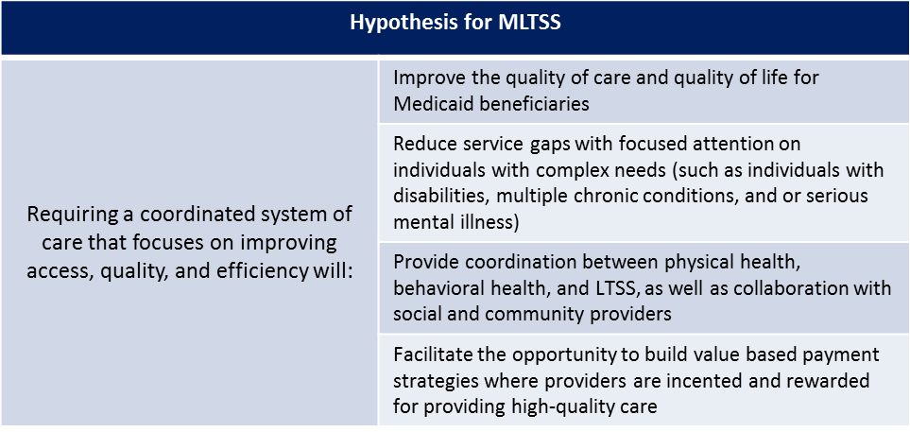
To obtain federal authority for this program, including the ability to mandate enrollment into the program, DMAS seeks a waiver of select provisions of §1902(a) as outlined in the following section, “List of Proposed Waiver Authorities and Sections.” To implement MLTSS, DMAS will solicit proposals from health plans to enter into fully capitated, risk-based contracts to administer the MLTSS program. DMAS will require that selected health plans: (1) employ a multi-disciplinary health care team approach to coordinating and facilitating care using health information technology which provides information to measure system and member-level outcomes; (2) implement a model of care that consists of health risk assessments, person-centered care planning, interdisciplinary care teams, care management and smooth transitions to and from hospitals, nursing facilities, and the community; (3) collaborate with community-based organizations and other community partners; (4) develop and maintain a provider network that is adequate to meet the needs of the individuals covered within the scope of MLTSS; (5) collaborate with providers through innovative, value-based payment arrangements where reimbursement is based on high quality outcomes; (6) measure and assess quality, outcomes, processes, and costs in partnership with the state, accepting joint accountability for system performance; and, (7) provide services and supports that are culturally competent and sensitive to the needs of the Virginia Medicaid population. Additionally, DMAS will require that selected plans have or achieve status as a Dual Eligible Special Needs Plan (D-SNP) in the localities in which the plan is selected to provide services. It will be expected that the plans work with DMAS to align, whenever possible, the enrollment of the dual eligible members in the same plan for both Medicare and Medicaid services. Selected plans will also be required to contract with DSRIP integrated provider partnerships, where geographically available, to provide an even greater level service to individuals who are most complex or high risk.
Initially, the demonstration will include approximately 50,000 dual eligible members, and approximately 20,000 non-duals who receive long-term services and supports. Individuals currently enrolled in the Commonwealth Coordinated Care demonstration will be enrolled upon the demonstration ending in December of 2017. Understanding the complexities of this population, the Department is proposing to utilize strategies reflected in the hypothesis, through an integrated benefit design where services will include primary and acute, long-term services and supports, behavioral health, and substance use disorder services. Care coordination is critical, and will be a cornerstone of the program. Health plans will be selected through a competitive procurement process. Finally, the program will be phased in, to assure diligence and focused attention on the Medicaid members.
The Department will utilize data sources including Medicare and Medicaid claims and encounter data. Data specifications will be outlined in contracts between DMAS contracted managed care entities and providers, where applicable.
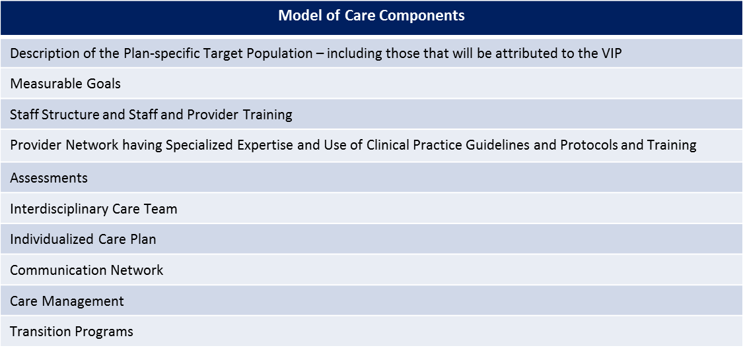
Having identified the populations to include in the MLTSS demonstration, DMAS proposes a phased in approach to enrollment that is expected to begin in March 2017 (discussed in later portions of this application). Once enrolled, individuals will be assigned to a health plan at which time initial assessments will be conducted and care plans determined. The coordinated system of care will focus on improving access, quality and efficiency. It is believed that the MLTSS demonstration will reduce service gaps through focused attention on individuals’ needs. Ultimately, the Department’s goal is to develop a managed care model that is designed to provide individuals with enhanced opportunities to improve their lives by:
- Promoting long term care options in community settings;
- Promoting community capacity and supports designated to better enable individuals to thrive in the community; and,
- Providing flexible and innovative benefit plans to serve individuals in their setting of choice.
MLTSS will operate under a fully integrated, person centered model of care that values quality, access, efficiency, and value based payment. With respect to the value of an integrated and coordinated system of care, DMAS will expect participating health plans to secure a provider network of both traditional Medicaid providers as well as LTSS providers.
The model of care expected to be utilized for this population is a significant component to the demonstration. LTSS members have unique and often individualized needs. These are frequently combined and compounded by other health and social issues.
For Medicaid beneficiaries who are eligible for both Medicare and Medicaid, there is great value in being able to coordinate both programs. MLTSS plans will be required to also offer D-SNP enrollment for Medicare-covered services. Once operational, Medicaid beneficiaries will have the option to choose the same plan for their Medicare and Medicaid coverage, achieving care coordination across the full continuum of care.
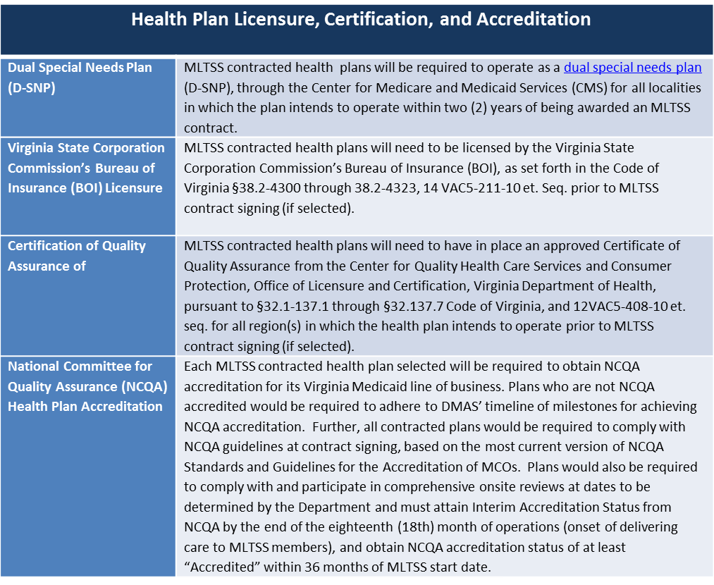
Understanding the vulnerability of this population and the importance of coordination between Medicaid and Medicare, DMAS plans to take a stringent approach on health plan licensure, certification, and accreditation- much like the one identified below. This strategy will help ensure the highest standard of quality in MCOs. In short, DMAS will require MLTSS MCOs to have appropriate licensure and certifications from the Virginia Bureau of Insurance (BOI) and Managed Care Health Insurance Plan (MCHIP) and MCOs will be required to obtain National Center for Quality Assurance (NCQA) accreditation.
MLTSS will require that health plans work with providers to negotiate value-based payment strategies that financially incent high-quality interdisciplinary care in the right setting, accelerate innovation to create value, and control the growth in spending. Through DSRIP, DMAS will focus significantly on supporting providers in transition to alternative payment models. Initial steps will be taken to evaluate readiness, identify supports needed, wrap supports around providers as they modify business practices and protocols, and then implement payment strategies that benefit Medicaid members, providers, participating MCOs and the state. DMAS’ MLTSS contract with the MCOs will include the requirement that MCOs work with providers to meet expectations and benchmarks for value based purchasing set by DMAS and CMS through the DSRIP waiver.

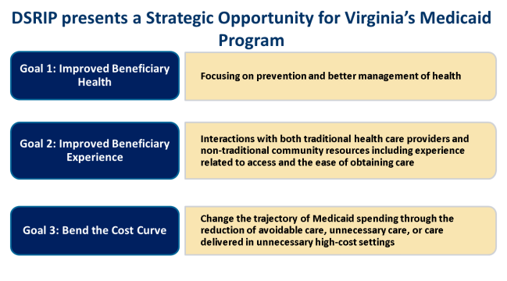
DSRIP Program Description
DSRIP is a strategic opportunity for Virginia to partner with the federal government and invest in the transition of the Medicaid payment and delivery system to ensure robust community capacity, integrated service delivery, and reimbursement based on the achievement of quality outcomes. Virginia will use DSRIP funding to transform the current system, so that Medicaid providers are financially incented to organize and deliver care in a way that results in healthier person-centered outcomes. As a result, Virginia’s rate of Medicaid spending will slow down.
Virginia believes the time is now to partner with CMS to transform the Commonwealth’s Medicaid delivery system. Providers in Virginia are responding to CMS’ transformation of Medicare payments and DMAS seeks to capitalize on this momentum. Through stakeholder engagement and departmental expertise, DMAS has identified the following goals for DSRIP.

Virginia Integration Partners (VIPs)
The first phase of Virginia’s DSRIP proposal will support the creation of high-performing, integrated partnership known as Virginia Integration Partners VIPs will share integrated care, data, processes, and communication and provide high-touch, person centered care for Medicaid’s highest utilizers and highest-risk enrollees. These partnerships will include medical, behavioral health, and long-term services and support providers, and also include care navigation and supports. Health systems focused on addressing enrollees’ complex needs will coordinate the VIPs. Transformational goals will be initially achieved through the VIPs.
These partnerships will be established through contractual arrangements between high performing public and private providers and include other community supports that are focused on high-touch care coordination. It is envisioned that community supports will be inclusive of but not limited to: Health Systems, Community Services Boards (CSBs,) Federally Qualified Health Centers (FQHCs), Area Agencies on Aging (AAA), Centers for Independent Living (CILS), and schools, where appropriate. The partnerships will also include care navigators, community health workers (CHWs), and be supported through a robust data driven care management system. These entities will work together to integrate the care and services needed to optimally support individuals with the most complex needs.
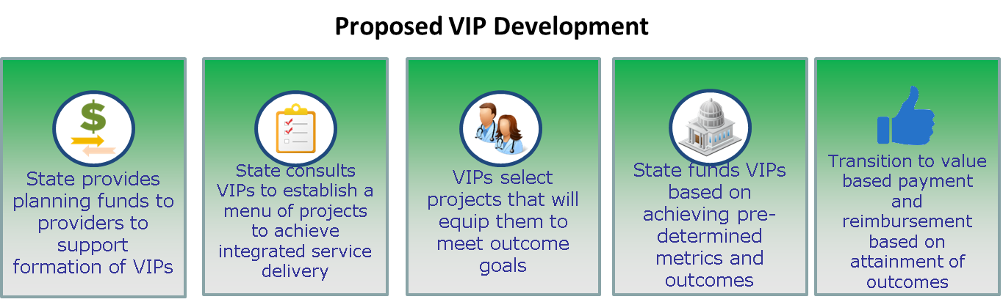
DSRIP funding will be used to support the transition of Medicaid payment methodologies to value based payment and reimbursement. To achieve this, VIPs will be developed based on seven core components:
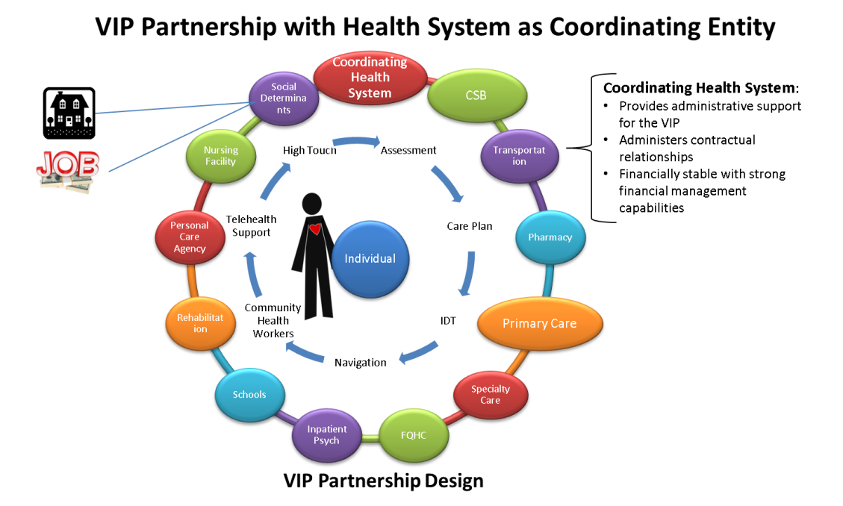
- VIPs will be supported to move to value based payment arrangements;
- All VIPs will establish a contractual relationship among VIP partners;
- All VIPs will participate in full data integration;
- VIPs will select projects and outcome targets from the determined project menu to achieve the DSRIP goals;
- The number of VIPs in Virginia will be determined by available funding, interest level and commitment;
- Initially, provider partners will maintain individual provider contracts with the MCOs; and,
- Ultimately, the VIPs will operate in an alternative payment arrangement with the MCOs such as total cost of care or other sustaining alternative.
- Each VIP will have a single coordinating entity, a health system that serves in this leadership role. The VIP, however, will be a separate legal entity from the coordinating health system. Understanding the responsibility of coordination is significant. The coordinating entity will have a contract with DMAS for DSRIP funding, and therefore the entity will be expected to have significant financial management capabilities.
Throughout this application, DMAS utilizes the terms ‘High Utilizer’ and ‘High Risk.’ DMAS defines these as stated below:
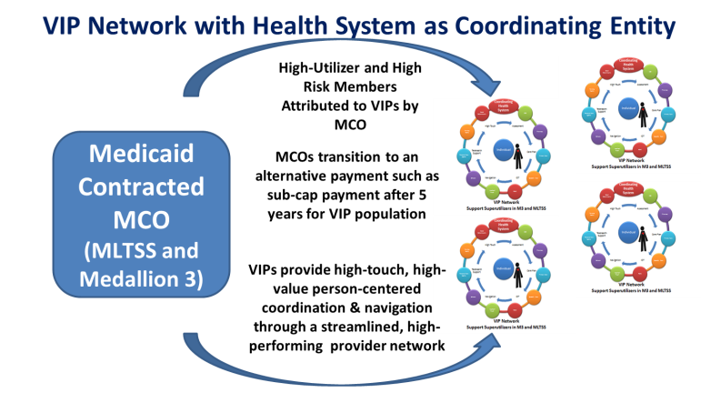
High Utilizer: High-utilizer is the term used to refer to Medicaid beneficiaries who have significant expenses due to high utilization of emergency departments and inpatient care (hospital, institutional) which may be prevented by less expensive early interventions, social supports, and primary care.
High Risk: There are two categories of high risk Medicaid beneficiaries.
- Medicaid beneficiaries, who do not engage in the provider community as needed, often do not follow medicine regimens as prescribed, do not follow up with physicians or specialty referrals and often refuse treatment if offered. These individuals often experience an acute episode, that is potentially preventable, and end up in costly and unavoidable inpatient settings.
- Medicaid beneficiaries who frequently engage the provider community, often unnecessarily, and in high-cost inappropriate places, such as the Emergency Department. It is often this subset of high-risk beneficiaries that become high-utilizers.

Affiliate Providers
Affiliate Providers will work with the coordinating entity of a VIP to access DSRIP resources. These providers will be seeking support for their transition to value based payment, but are not in the position to move to a total cost of care payment within the next several years. These providers will be able to access resources to enhance their data infrastructure and participate in shared learning and educational resources that will enable their transition to value based payment. These providers will not be part of that coordinating entity’s VIP, but will use DSRIP resources to be positioned to enter into other value based payment arrangements with Medicaid health plans.

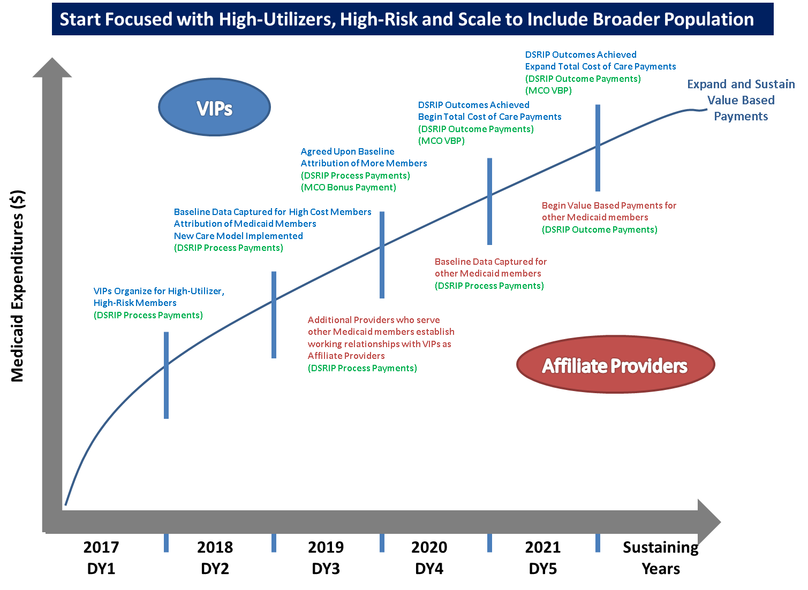
DMAS seeks to utilize the VIP structure and support of Affiliate Providers to test the following hypotheses. VIPs will select from a menu of projects that will be finalized in the Standard Terms and Conditions to achieve the goals and measures outlined below. Affiliate Providers will be supported to transition to value based payment arrangements with health plans and will contribute to the fundamental goal of bending the cost curve.
To fulfill Virginia’s commitment to “Think Big, Start Focused, and Scale Fast,” DSRIP will be implemented through a two pronged approach. First, Virginia will facilitate development of formal partnerships of high-performing providers to provide high-touch, integrated care to a subset of Medicaid managed care beneficiaries who are the highest-risk, highest utilizers. This prong will be self-sustaining by the end of the demonstration period through transition to a total cost of care payment or similar alternative payment model with the enrollee’s health plan.
Second, beginning in year three, additional providers, known as “Affiliate Providers” can leverage DSRIP data infrastructure and learning resources to enable their transition to value based payment. These providers will not formally be part of their community’s VIP, but will access a more limited portion of DSRIP resources through the coordinating entity. Affiliate Providers will contract with health plans to engage in value based payment strategies such as episodes of care.
DMAS is planning this two pronged approach to initially focus on the population where the greatest costs and greatest opportunities to improve care exist. Virginia will then quickly scale the program to benefit a greater number of enrollees. Initial analysis indicates that roughly 1% of enrollees drive 22% of program costs and 5% of enrollees drive over 50% of costs. Preliminary data indicate that 72% of these enrollees were high cost in the preceding year. This means that they can be identified and supported to receive enhanced care. Further, 72% of the highest utilizers had a behavioral health diagnosis. This further directs Virginia to develop a program that focuses on addressing behavioral health and complex needs, first.
The goals of the VIPs align with the goals for MLTSS. A significant portion of the MLTSS population (Medicare-Medicaid enrollees and individuals accessing LTSS) are high-risk or high-utilizers. Contracted health plans in MLTSS will provide population health services, assessment, and care coordination. The subset of the MLTSS population made up of high-risk, high-utilizers will receive even more focused high-touch coordination and navigation through a VIP, where geographically available. The individual will remain enrolled in the MLTSS plan, but received enhanced care delivery through the VIP.
Individuals who are high-risk, high-utilizers in the Medallion 3.0 program will also be attributed by their health plan to the VIP, where geographically available. The VIP will work with the Medallion 3.0 health plans to provide enhanced services and coordination for the enrollees. At the end of the five year waiver demonstration period:
- The enrollee will benefit from an enhanced level of high-touch, person centered care and navigation across the complex landscape of medical, behavioral health, social, and long-term services and supports.
- The health plan will benefit from having its highest utilizers receive a heightened level of data-driven complex care management and in-person navigation across a focused spectrum of high-performing providers.
- The VIP will benefit from having additional resources to address the often extremely complex needs of the Medicaid population and support their transition to a data-driven, well organized care delivery system.
There are many communities throughout Virginia that have already considered a similar concept, and some are already participating in similar arrangements through Medicare Accountable Care Organizations (ACOs). While this opportunity will not replicate what is already in place, DMAS intends to build upon lessons learned and best practices of these models in an aim to build and deploy strong VIPs, ready to work together to serve Virginia Medicaid’s most complex enrollees.
DMAS recognizes that in the existing model, providers do not have time to deviate from the traditional fifteen minute patient visit, making it difficult to adequately care for patients who have complex conditions. DSRIP will help develop care models that incent providers to modify care delivery so that they can appropriately allocate time and resources to each Medicaid beneficiary and develop a plan to care for and be reimbursed appropriately to provide care for complex Medicaid enrollees.
Through the support of DSRIP, the Commonwealth plans to invest in the provider community and intends to make sure that the impact is lasting and meaningful. DMAS and its partners will spend a significant amount of time in the first year of the demonstration, working with interested stakeholders to develop a governance structure and refine all necessary policies, protocols, contracts, and expectations to ensure successful implementation of VIPs throughout the Commonwealth. Additionally, participating VIPs must demonstrate that there is a sustainability plan in place to ensure that contractual arrangements with proven partners (public and private entities) will last when the 5 year DSRIP waiver demonstration ends.

Testing the Hypothesis for DSRIP
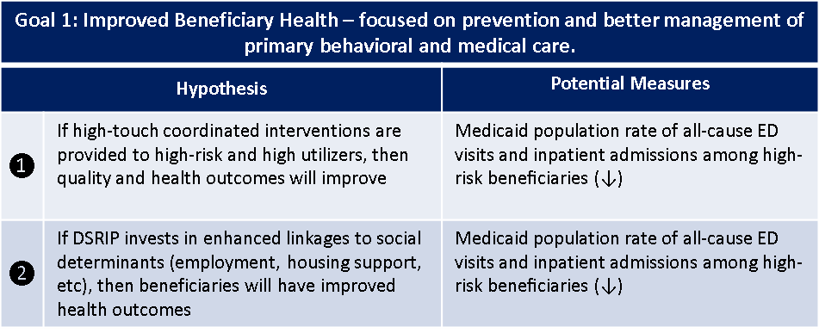
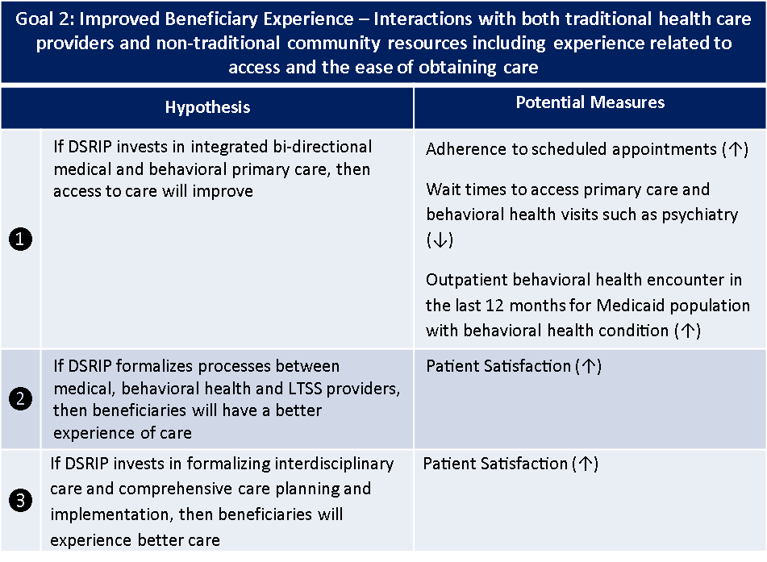
To support the proposed DSRIP program design, DMAS has identified the following hypotheses and potential measures. Program design is predicated on a number of hypotheses. As a demonstration waiver, DMAS has the opportunity to test these hypotheses to help define this program and refine the development of programs in the future.

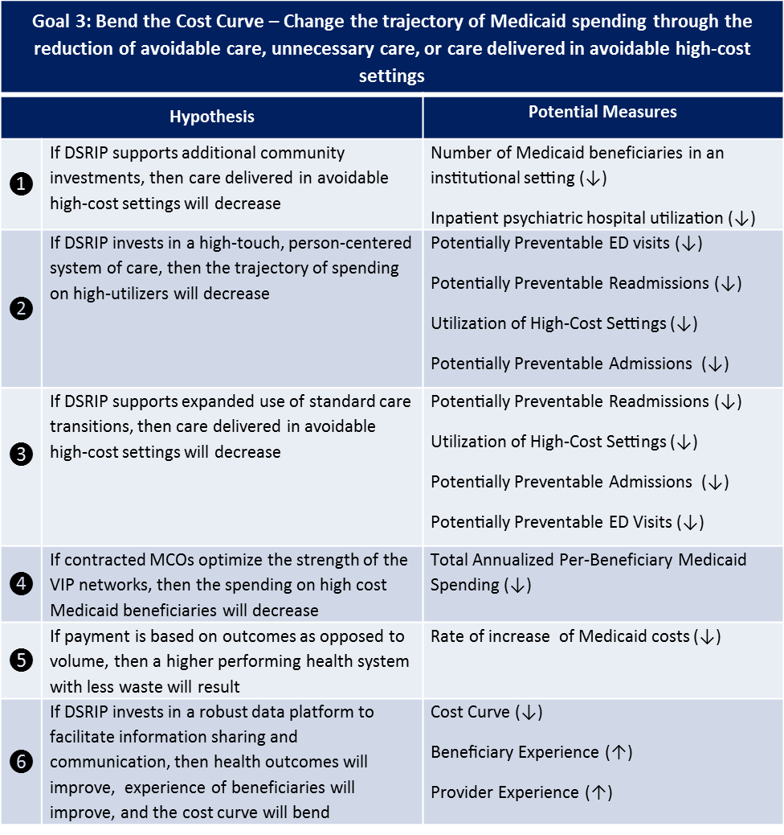
System Transformation Projects
DSRIP system transformation projects are focused on the establishment of VIPs, development of the VIP model of care and ensuring that the provider capacity exists to support the care model, and data integration and utilization.
A.1 and A.2 - Establish VIP delivery partnerships in select geographic regions across the Commonwealth and Establish VIP model of care and preferred care pathways between VIP providers
The preceding section detailing the “Proposed VIP Development” outlines the establishment of VIP partnerships and care model and addresses System Transformation Projects A.1 and A.2.
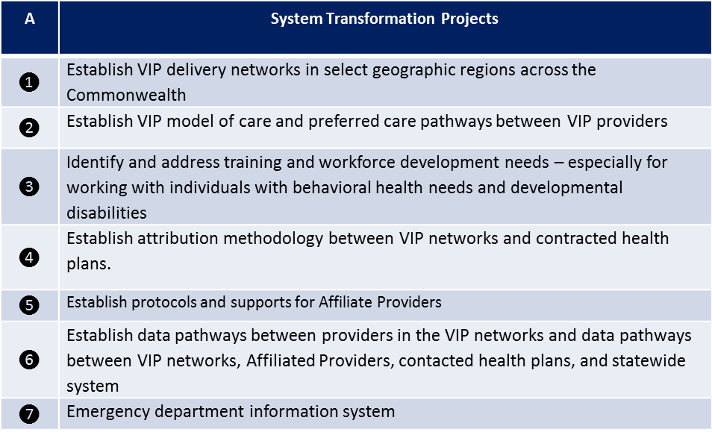
A.3 - Identify and address training and workforce development needs – especially for working with individuals with behavioral health needs, and developmental and physical/sensory disabilities. DMAS recognizes that training of Virginia’s workforce and caregivers/peers/health workers is critical for Virginia’s communities to have the breadth of expertise to care for the entire Virginia Medicaid population. DSRIP will support workforce training for medical professionals, including school based providers where appropriate, to help meet this need. Training will be developed so that behavioral health can be integrated as an extension of primary care. Additionally, resources will be focused to ensure medical professionals are trained so they are competent and confident to work with individuals of all ability levels, as appropriate.
Not only will a focus be on training the existing workforce, but there will also be efforts to strengthen the provision of training designed to aid in addressing the concerns of adequate capacity and geographic access needs throughout portions of the Commonwealth. Virginia envisions expanded investment into disciplines such as: nurse practitioners (including psychiatric NPs), EMS workers, addiction specialist, caregivers, peers (individual and family), and community health workers. DMAS recognizes that schools are often a central point of care for many children with complex needs who receive Medicaid. DMAS will seek to use DSRIP funding to develop continuing education models that ensure that school nurses are trained to meet the most demanding needs of these children (diabetes, asthma, behavioral health, etc.) and are able to more appropriately partner with other community providers when caring for Medicaid members in the school setting.
A.4 – Establish attribution methodology between VIP partnership and contracted health plans
DMAS will work with its contracted health plans and VIPs to determine how to best leverage the strength of the VIPs to enhance care delivery to the most complex MLTSS and Medallion 3.0 Medicaid enrollees.
A.5 – Establish protocols and supports for Affiliate Providers
DMAS will work with VIP coordinating entities to identify protocols and expectations for providers seeking to obtain status as an Affiliate Providers. This will include contract terms, process and outcome goals, and expectations for value based payments.
A.6- Establish data pathways between providers in the VIP partnership and data pathways between VIP partnership, contacted health plans, and statewide system
A shared technology platform is critical when engaging in a team based care approach and model. Further, shared information facilitates better patient experience, and decreases waste within care development and assessment processes. DSRIP will allow DMAS to work with participating VIP partners to leverage and build upon existing systems and resources and develop an optimal data system that will:
- Establish data-readiness for providers to conduct team-based care;
- Establish data-readiness for providers to be reimbursed for outcomes;
- Develop close to real-time data exchange between providers;
- Develop capacity for business intelligence; and,
- Develop capacity for data analytics.
In order to successfully achieve all of the proposed DSRIP strategies, Virginia’s Medicaid providers need to be better supported in their ability to capture, report, and analyze their Medicaid member data and information. Virginia will use DSRIP to help VIPs build an integrated clinical, behavioral, social, and support data platform to accelerate provider integration and enable value-based payment models (later explained). DMAS plans to support a needs assessment of the Medicaid provider community as it pertains to needed data support from DMAS. DMAS will use DSRIP funding to accomplish its goals for data analytics, beneficiary information exchange, and revised payment structure with a single statewide support structure.
Virginia’s proposal aligns succinctly with the recently published Federal Health I.T. strategic plan. Specifically, Goals 1 (Advance Person-Centered and Self-Managed Health) and 2 (Transform health Care Delivery and Community Health) and the associated objectives can be leveraged to support the identified need for a single statewide support structure, that will connect providers, payers, members, and DMAS.
DMAS will use DSRIP funding to design the data architecture and build the data platform that will enable providers to connect with each other, and payers while tracking outcomes of Medicaid members to be utilized for reimbursement strategies of value based care.
In addition to the data system development, there will also be support for providers and managed care organizations to link to each other and a statewide care management system, which will serve as the backbone to the integrated care vision for Virginia’s Medicaid members. Today, if a Medicaid member exercises their choice to change MCOs, the care management data is not transferred to the new MCO, resulting in a significant duplication of effort and testing for the member. This is cumbersome and wasteful for the Medicaid agency, but most importantly, time consuming for Medicaid providers and beneficiaries. The proposed care management system will provide the transparency and data needed to move Virginia towards value-based payment arrangements within the Medicaid program.
DMAS understands that significant information technology investments have been made by providers across the Commonwealth. DSRIP will afford the opportunity to build a Data architecture platform that will facilitate connectivity of these individual provider systems, not duplicate, replicate, or make insignificant the investments of providers, to date.
Further, Virginia seeks to develop a statewide set of minimum data standards. Across the healthcare continuum to include the partnership with the MCOs, there are hundreds of data elements measured and reported by Medicaid providers and MCOs. While these data sets are all valuable in their own catchment, there is significant duplication of effort due to gaps in taxonomy and uniformity in reporting requirements. DMAS proposes using DSRIP support to bring together key partners across Medicaid and the commercial sectors in order to undertake a statewide effort to establish a uniform set of minimum data standards (MDS). Standardization is a cornerstone of meaningful data analysis. Virginia aims to utilize data analytics to improve care and institute value based payments which reward providers for the delivery of quality care to Medicaid members.
A.7 – Emergency Department Information System
DSRIP investment will flow through the VIP partnership; however, a significant component to improved care and financial savings is the ability to quickly share information between emergency departments- including those outside of the VIP partnership. Virginia seeks to identify a VIP that will lead the implementation of a statewide (or near statewide) electronic health record platform for emergency departments. A shared emergency department information system will reduce medical errors, expedite care, reduce redundant testing, and improve care.

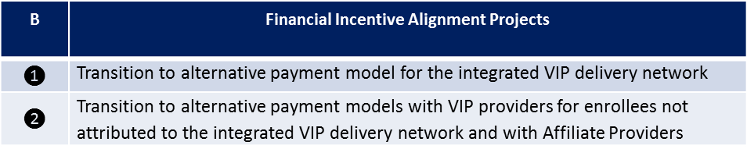
Financial Incentive Alignment Projects
DSRIP financial incentive alignment projects are focused on transitioning the Medicaid system to value-based and alternative payment models. DMAS does not believe that it is responsible to expect the magnitude of change anticipated in the payment structure without supporting Virginia’s Medicaid providers through the transition.
Funding to support provider transition to alternative payment models will flow through the VIPs. Providers participating in VIPs will receive support to transition to alternative payment models in two ways: (i) As a streamlined VIP delivery partnership for high risk, high-utilizers with the goal of moving to a self-sustaining global sub-capitation or similar alternative payment arrangement at the end of the five year waiver period; and (ii) As an Affiliate Provider. Affiliate Providers are Medicaid health plan-contracted providers that will receive support to implement additional alternative-payment models. Value based payment will be part of the MLTSS and Medallion 3.0 contracts over the demonstration period.
Virginia intends to use DSRIP to develop and test payment methodologies through the VIPs and with VIP providers - which are a subset of the Medicaid provider network. Through DSRIP, DMAS will identify strategies with the highest return on investment and likelihood of self-sustainability. At the end of the waiver period, DMAS will work with additional providers and health plans to replicate and scale documented best practices throughout the provider network.
B.1 – Transition to alternative payment model for the integrated VIP delivery partnership
DSRIP funding will support the development of the integrated VIP partnership and care model for high-risk, high-utilizers. This high-performing partnership of providers will transition over a five year period to a sub-capitation arrangement or other alternative payment arrangement with contracted health plans. VIPs will be designed to meet the complex behavioral, social, and medical needs of this population and will need to invest in supports and services that are not historically paid for by the Medicaid program. Payment models will be developed to reflect this and in a way that best meets enrollees’ needs and decreases utilization of expensive avoidable medical services. DMAS is designing its DSRIP VIP program to meet the needs of Virginia’s most complex enrollees – those that will be enrolled in MLTSS- but also plans to use its VIP system and alternative payment methods for complex enrollees in its Medallion 3.0 health plans.
DMAS anticipates that any value based purchasing methodology will be based on quality and outcome performance measures. Measures will initially be more process oriented. Payments for enrollees attributed to the VIPs will evolve to progressively higher risk, total cost of care models.
B.2 - Transition to alternative payment models with VIP providers for enrollees not attributed to the integrated VIP delivery partnership and Affiliate Providers
Only individuals designated as high-risk and high cost will be attributed to the formal VIP partnership. The majority of enrollees a VIP Medicaid provider sees will be outside of the VIP arrangement, yet still may experience significant episodes of care or have chronic conditions to manage. Further, Affiliate Providers will not be part of the formal VIP, but will still be moving to value based payment. DMAS will leverage DSRIP to work with the VIP providers, Affiliate Providers, and health plans to develop alternative payment arrangements, such as episodes of care and bundled payments, to improve care for these enrollees. For example, this could a bundled payment for all maternity care and delivery. These payment models will be developed in collaboration with providers and health plans and tied to the clinical improvement projects included in DSRIP.

Preliminary DSRIP Transformation Project List
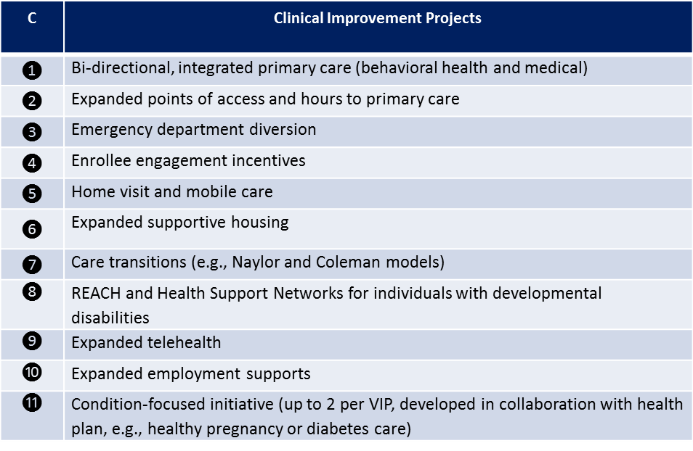
The information below contains highlights of select DSRIP Clinical Improvement Transformation Projects. The projects listed will be formalized and related measures, established, during the Special Terms and Conditions development process. DMAS will do this in consultation with VIP coordinating entities, providers interested in partnering with a VIP, contracted health plans, SIM workgroups, self-advocates, and CMS.
C.1- Bi-directional, integrated behavioral health and primary care (High-touch coordinated interventions),
Team-based, integrated behavioral health and primary care aims to increase interdisciplinary care teams (including public and private providers) so that holistic, person-centered care becomes the standard practice for Medicaid enrollees. Additionally, there will be a focus on integrating primary behavioral health and medical care so that behavioral health is a natural extension of primary care and primary care is a natural extension of behavioral health. This will be a bidirectional approach, understanding that individuals will initiate care where they are most comfortable, be it a center or practice whose main focus is behavioral health, or physical health.
DMAS recognizes that in many practices, the availability of a clinical social worker, or other experts such as psychiatric nurse practitioners, integrated into the care practice, will dramatically enhance the ability of the practice to follow up and wrap behavioral health and social supports around individuals in need of behavioral health care. Behavioral health practices will greatly benefit from the infusion of primary care practitioners into their practice model. This team based approach will facilitate a stronger, bidirectional care model, no matter where Medicaid beneficiaries choose to access their care.
It is believed that the ‘high touch’ approach to this concept recognizes the importance of face to face care by providers in the community. Depending on the expressed needs of the Medicaid beneficiary, the ‘high touch’ support could be either a social worker or other social support professional, or a medical professional. The flexibility of the VIP partnership will allow for the person centered planning approach to determine what the best fit is for the individual, facilitating positive interactions and appropriate engagement of the Medicaid provider community.
Formalized processes between medical, behavioral health and LTSS providers will translate into beneficiaries being able to access better care, which translates into a better experience of care, yielding better health outcomes for Virginia’s Medicaid beneficiaries. It is expected that where appropriate, beneficiaries will be engaged in their health care, and the VIP providers and participating MCOs will work together to determine the best engagement strategies and incentives to ensure beneficiaries are actively engaged in their health and health outcomes.
C.2- Expanded hours and access to primary medical and behavioral health care
The care model proposed through DSRIP recognizes the importance of access to care, especially for individuals supported by family caregivers and those with behavioral health needs. While DMAS understands the need to support providers in the development of extended hours, due to overhead costs, and staff turnover risk, there is strong evidence that expanding access to primary medical and behavioral health care will ultimately reduce the overreliance on emergency department use and preempt acute episodes that result in hospitalization. DMAS will likely require this project of VIP partnerships and will encourage VIP providers to work together to determine the best model to ensure equity in time spent and cost incurred as a result of this project.
C.3- Emergency Department Diversion
Throughout Virginia, individuals often rely on emergency departments (ED) to receive non-emergency care. This occurrence is often compounded by individuals who experience Serious Mental Illness (SMI) and other behavioral health conditions. This reality is often the result of a lack of access to primary and behavioral health care. Additionally, there are individuals who are high utilizers of inpatient hospital care. DMAS proposes to utilize DSRIP funding to support the VIPs’ implementation of protocols that increase access to patient navigation tools, strengthen hospital coordination efforts, and extend office hours through partnering primary care practices. This could also include working with local Fire and Rescue and Emergency Medical Technicians to develop innovative ways to build upon their skill sets.
C.4- Enrollee Engagement Incentives
Virginia supports the concept of patient engagement, or in this domain, beneficiary engagement, yielding better health outcomes and more efficient use of the health system. DMAS recognizes that strategies developed in this domain must be effective, not only for the motivation of engagement but also for the entity responsible for tracking engagement. Tracking minimal copayments or other penalties previously explored with Medicaid populations, often yields significant administrative burden with little to no ultimate behavior change. To that end, DMAS will work with VIPs to identify incentives to motive Medicaid beneficiaries to engage the health care system in more appropriate ways.
C.5- Home Visit and Mobile Care
DMAS, along with sister state agencies and community partners, has been working diligently over the past decade to strengthen the connection of individuals who live in the community to the providers and support services that care for them. In many communities this connection is best served by a mobile care team and there is a need to further support and multiply the number of mobile care teams throughout the Commonwealth. Through DSRIP, Virginia intends to increase access to primary and behavioral health care in all geographic regions by increasing mobile clinics and/or providers. Another targeted approach will be to increase access to primary and behavioral health care to adults and children with limited mobility or who are otherwise hard to reach, through home visits. Essentially, DMAS will look to the VIPs to put their resources on wheels and engage and provide care throughout Virginia’s communities.
DMAS is aware of the current use of community health workers and believe a resource, such as this, could health ease the constraints on providers who would need to dedicate staff and time to a mobile unit. DMAS will work with the VIP partnerships to establish standards and protocols that meet both the expectation of federal partners, and feasibility of the provider community.
C.6- Expanded Supportive Housing
The Department believes that housing is healthcare. While Medicaid is not allowed to pay for housing, Virginia desires a clear statewide process for identifying and disseminating appropriate and available safe housing options for Medicaid enrollees. DMAS is committed to working with statewide experts and partners to ensure Virginia’s policies are appropriate and person-centered. Through DSRIP, Virginia intends on identifying a preferred solution, to make this information available to providers, care managers, and the individuals who are in need of housing, or better housing options.
- 7- Care Transitions and Diversions from Institutional Care
Institutional care is valuable to the Medicaid program for individuals who are truly in need of highly monitored, comprehensive care in a residential facility. Virginia, however, is not unlike other states in the country, where there is a legacy and history of institutional bias, even today when there have been decades of efforts to strengthen the community options for individuals who have a level of care need that formerly would have triggered institutional care. As a result, care transitions often default to relying on institutions as a hospital discharge alternative.
In addition, when an individual is ready to transition from an institution back into the community, care transitions are often difficult to manage and Medicaid members are at risk of confusion, chaos, and readmission to the institution. DSRIP will be used to facilitate better relationships and communications between community partners, in place to support Medicaid members in the community. Virginia will seek to implement best practices and principles such as, but not limited to; the Coleman Model or the Transitional Care (Naylor) Model, to increase success when transitioning Medicaid members between care settings (e.g. hospital discharge, nursing facility to home/community, Psychiatric Residential Treatment Facility (PRTF) to home/community). In order to best support providers and individuals who are transitioning, protocols will be refined and pathways will be developed to ensure that home and community based services and supports are easy to both establish and maintain. DMAS will work with VIPs and other community partners to develop these processes.
C.8- Expanded REACH
REACH is a program to support adults with intellectual and/or developmental disabilities, as well as a mental health condition or challenging behavior that is negatively affecting their quality of life. REACH programs are offered across Virginia. REACH provides consultation, mobile support, and therapeutic home services to individuals ages 18 and above with documented evidence of an intellectual or developmental disability & mental health or behavioral needs among five regions in the Commonwealth. REACH emphasizes the prevention of crises before they occur. This prevention is done through early identification of individuals in need of service, development of crisis response plans, trainings, and technical assistance. REACH programs are also under development in these regions for children.
C.9- Telehealth
Virginia is one of the leading states in the country when it comes to utilization of telehealth as a mode of Medicaid care delivery. While we celebrate the successes of this accomplishment, there are significant opportunities to strengthen the use of telehealth in order to better support Virginia’s Medicaid members and the providers that care for them. Through DSRIP, Virginia seeks to strengthen home monitoring for chronic condition management, long-term services and supports, and intends to deploy resources and tools, to aid in crisis prevention and beneficiary safety. Telehealth has the ability to make preventive health screenings more timely and accessible, both incredibly valuable when focusing on sustaining health and wellness. With the extended focus towards integration of care, telehealth has the ability to enhance access to providers, especially for behavioral health treatment. Further, Virginia seeks to expand the ability of providers to consult with expert and specialty care providers.
C.10- Expanded Employment Supports
In addition to housing, employment is desired by many Medicaid beneficiaries, and considered to be an important piece of meaningful community living. DMAS intends to build off of the existing Medicaid Works program and use DSRIP to enable investment in the development of partnerships with representatives from the business community as well as workforce training experts, such as the Virginia Disability, Aging, and Rehabilitation Services (DARS) agency, in order to make sure that the Commonwealth has an established process for recruiting and connecting Medicaid members to employers committed to employing individuals with Serious and Persistent Mental Illness (SPMI) and other varying abilities.
In October, 2015, Virginia received a $4.3 million federal grant from the U.S. Department of Education to help nearly 500 Virginians with disabilities gain new skills and credentials to seek employment in competitive, high-demand, high-quality occupations. The five-year grant will allow (DARS) and the Department for the Blind and Vision Impaired (DBVI) to develop and implement a demonstration project to enhance Virginia’s existing regional career pathways systems to serve individuals with disabilities. This may overlap with demonstration beneficiaries; however, lessons learned and strategies developed will translate well into the objectives of this DSRIP strategy. Mirroring the process for housing, DSRIP funding will also be used to make developed employment strategies and information available to providers, care managers, individuals, and family members.
C.11- Condition-focused Initiative (up to 2 per VIP developed in collaboration with health plan, e.g., healthy pregnancy or diabetes care)
As described previously, at its core, the VIP model relies on a high-touch, person-centered system of care. As exemplified in the project highlights, DSRIP intends to invest in this ‘high-touch’ model, supporting the provider community in their efforts to expand their existing care models, and strengthen the existing care transition efforts. This care approach will translate into more engaged Medicaid beneficiaries, and more accountable providers.
Unified Waiver Approach
DMAS is proposing to utilize this opportunity to retool the Medicaid program in order to better integrate care provided to Medicaid members, while substantiating a data system that will ultimately support the successful movement to value based payment models. While the MLTSS and DSRIP efforts are unique in some project components, the opportunity to combine these efforts will result in a strong, robust, Medicaid delivery system. Integrating the efforts of all Medicaid providers, the MCOs that facilitate payment of services, and the Department, will allow for better care delivery and better member experience for Virginia’s Medicaid beneficiaries. DMAS begins these strategic efforts, with the member’s health and wellness at the forefront of all decision making.

Required application elements by Centers for Medicare and Medicaid

Geographic Coverage
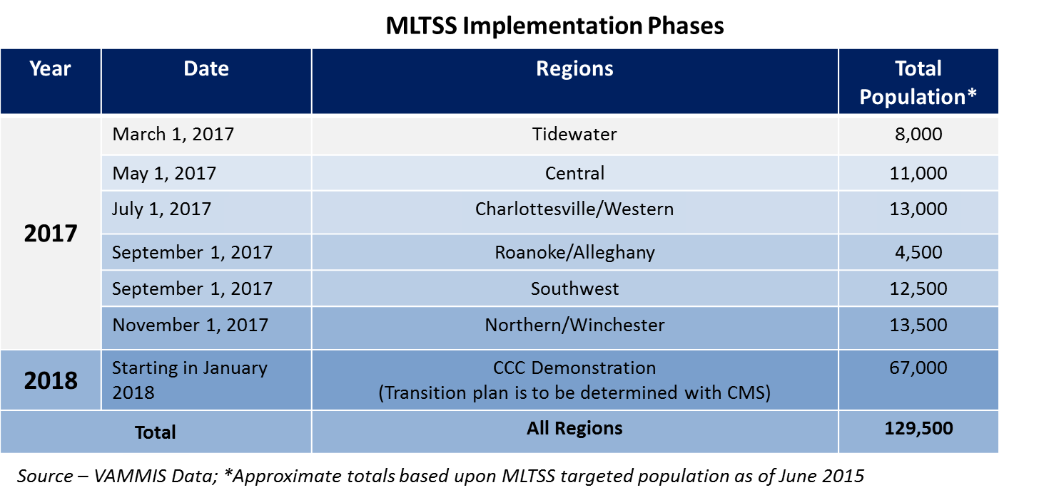
MLTSS: The MLTSS effort will be statewide, though the rollout will be regional. The regional approach will ensure that the participating health plans, along with DMAS, have the appropriate resources needed to in order to achieve a successful implementation and most importantly a safe implementation for the Medicaid members. The table below highlights the regional approach, based on region and population type.
DSRIP: The implementation of the DSRIP demonstration will be in a number of geographic areas around the state. The VIPs will likely focus in areas of higher population density, however, some rural areas will be included. Affiliated Providers will likely be based in the same geographic area as the VIP; however, Affiliated Providers may also be used to expand the geographic reach of Virginia’s DSRIP. The Department will negotiate specifics of this strategy in the agreed upon Special Terms and Conditions and use these standards to finalize arrangements with VIP provider partnerships. To date, a number of health systems have expressed interest in becoming coordinating entities. DMAS will continue to engage interested health systems as the Special Terms and Conditions are developed.
§1915(c) Home and Community Based Services Waivers: The proposed migration of the Alzheimer’s Assisted Living Waiver (Alzh), Elderly or Disabled with Consumer Direction (EDCD) and, Technology Assisted Waiver (Tech) waiver authorities will alter neither eligibility nor services under these three waivers. Additionally, the waivers will operate statewide, as they do under the§1915(c) authority.

Demonstration Eligibility
Eligibility for individuals who qualify for the program demonstrations will not be altered from eligibility determination processes and protocols that currently exist. Additionally, there are no proposed enrollment limits. Individuals who receive improved care through a DSRIP initiative include a subset of those currently enrolled or eligible for MLTSS and Medallion 3.0.

Provide the projected number of individuals who would be eligible for the Demonstration, and indicate if the projections are based on current state programs

MLTSS: The projected number of individuals eligible for the MLTSS portion of the demonstration is 129,500. These projections are based on current state enrollment of both state plan and six 1915(c) waivers. Broadly, the populations included in the MLTSS demonstration are:
- Approximately 46,000 Dual Eligibles excluded from the CCC demonstration
  - Full Medicaid and any Medicare benefits
  - Nursing facility and HCBS Waivers
- Approximately 18,000 Non-Duals with LTSS
  - Nursing facility and HCBS Waivers
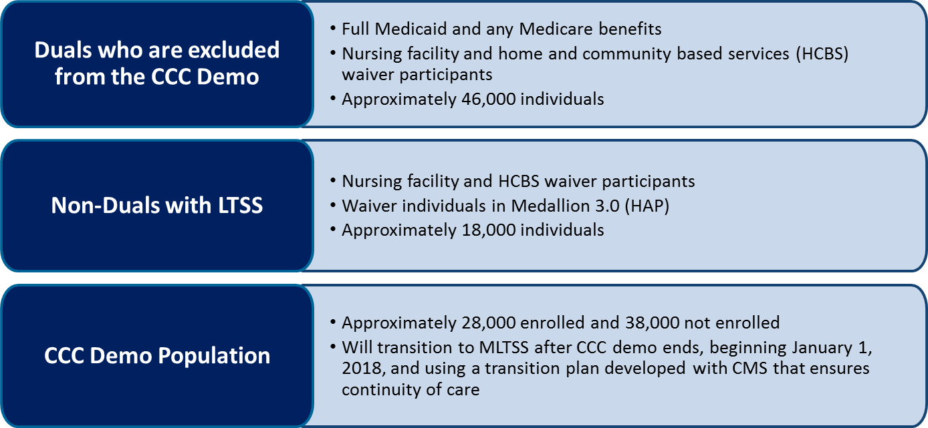
  - Waiver individuals in Medallion 3.0 (HAP)
- Approximately 66,000 individuals in the CCC Demonstration Population
  - (28,000 enrolled and 38,000 eligible/not enrolled)
  - Transition from CCC to MLTSS after CCC demonstration ends; January 1, 2018
DSRIP: DSRIP will include a subset of the MLTSS population and the Medallion 3.0 population. This subset will include high risk, high utilizers who will be attributed by the health plans to the VIP partnership. This population will make up an estimated 1-5% of Medicaid enrollees. Individuals who experience a chronic condition or episodic care event and receive care from a provider who participates in a VIP partnership may also be included in an alternative payment methodology through DSRIP. The number of individuals impacted will vary depending the number of VIP partnerships and their geographic availability, the finalized VIP partnership attribution model outlined in the Special Terms and Conditions, and the alternative payment models developed with VIP providers and health plans outside of the formal VIP partnership.
§1915(c) Home and Community Based Services Waivers: The projected number of individuals eligible based on waiver enrollment as of October 31, 2015 for the following waivers total 32,730 individuals:
- Alzheimer’s Waiver
  - Enrolled: 57
- Technology Assisted
  - Enrolled: 287
- Elderly or Disabled with Consumer Direction
  - Enrolled: 32,386

Demonstration Benefits and Cost Sharing Requirements
Indicate whether the benefits provided under the Demonstration differ from those provided under the Medicaid and/or CHIP State plan:

MLTSS:
Yes No (if no, please skip questions 3 – 7)
DSRIP:

Yes No (if no, please skip questions 3 – 7)

§1915(c) Home and Community Based Services Waivers: While differing from the Medicaid/CHIP state plan, benefits will not be altered as currently available under the existing 1915 (c) authority.
Yes No (if no, please skip questions 3 – 7)

Indicate whether the cost sharing requirements under the Demonstration differ from those provided under the Medicaid and/or CHIP State plan:

MLTSS:
Yes No (if no, please skip questions 8 - 11)
The MTLSS portion of this demonstration will follow the cost sharing decision authorized under the CCC demonstration. Because DMAS will require that participating MCOs also be certified as DSNPs, there will not be a requirement for any patient pay or cost sharing obligation.
DSRIP:
Yes No (if no, please skip questions 8-11)
The DSRIP portion of this demonstration will exercise the opportunity to explore and subsequently implement a patient engagement strategy that requires Medicaid members to be active in their health care. DMAS will work with VIP partnerships and MCO partners to determine the best incentive strategies to encourage positive member engagement.

§1915(c) Home and Community Based Services Waivers:
Cost sharing requirements for this portion of the demonstration will not alter from those currently recognized under existing 1915(c) authority.
Yes No (if no, please skip questions 8-11)
Indicate whether Long Term Services and Supports will be provided.

MLTSS: While LTSS will be provided, they are not different in scope than those already authorized through the State Plan for Medical Assistance or Existing Waiver authority, therefore this question is not applicable

DSRIP: While LTSS will be provided, they are not different in scope than those already authorized through the State Plan for Medical Assistance or Existing Waiver authority, therefore this question is not applicable
§1915(c) Home and Community Based Services Waivers: not applicable as demonstration is not seeking to alter from existing benefit specifications and qualifications; see 1915(c) authority
Include a table if the Demonstration will require copayments, coinsurance and/or deductibles that differ from the Medicaid State plan also include any proposed cost sharing strategies.

MLTSS: The demonstration proposal does not differ from the state plan
DSRIP: As noted above, the DSRIP portion of this demonstration will exercise the opportunity to explore and subsequently implement a patient engagement strategy that requires Medicaid members to be active in their health care. DMAS will work with VIP partnerships and MCO partners to determine the best incentive strategies to encourage positive member engagement.
§1915(c) Home and Community Based Services Waivers: does not differ from existing §1915(c) waiver authority.

Delivery System and Payment Rates for Services
Indicate whether the delivery system used to provide benefits to Demonstration participants will differ from the Medicaid and/or CHIP State plan:
MLTSS: The delivery system used to provide benefits to the Demonstration participants in the MLTSS portion of the waiver will transition the majority of remaining fee-for-service services into a mandatory managed care environment. A detailed explanation of the proposed delivery system is identified in earlier sections of this document.
DSRIP: The delivery system used to provide benefits to the Demonstration participants in the DSRIP portion of the waiver is described in detail in earlier sections of this document.
§1915(c) Home and Community Based Services Waivers: The operational authority sought through the migration of administrative authority from an existing 1915(c) to 1115 waiver authority does not alter how benefits are provided to these traditional 1915(c) waiver beneficiaries.
Describe how the managed care providers will be selected/procured
MLTSS: For the MLTSS portion of the demonstration, Managed Care Organizations (MCOs) will be selected through a competitive procurement process. The Request for Proposal will be released in spring of 2016 with an anticipated rollout of the demonstration, upon CMS demonstration approval, in January of 2017.
DSRIP: The DSRIP demonstration will utilize the MLTSS procured plans as well as those currently participating as Medallion III MCOs. MCOs will have a role in the DSRIP demonstration as partners in the integrated care partnerships.
§1915(c) Home and Community Based Services Waivers: not applicable as waiver authority is for administrative purposes only.

Demonstration Financing and Budget Neutrality
Section 1115 waivers are generally approved for a 5-year period and must be budget neutral to the federal government—meaning that, over the course of the waiver, federal Medicaid expenditures will not be greater than they would have been without the waiver. To build its DSRIP investment pool, Virginia is proposing to leverage a portion of savings accrued to the federal government as a result of state strategies previously employed to constrain the rate of Medicaid spending. Through providing managed care choices for a percentage of Virginia Medicaid enrollees through Medallion 3.0, and rebalancing the long-term care system from institutional to community based settings, Virginia has achieved federal savings of $2.3 million from 2004 through 2017 and will achieve additional federal savings of $1.7 billion from 2018 through 2022.
The Medallion 3.0 savings assumes that managed care has saved at least 5% from what would have been spent under FFS. Savings from Long-Term Services and Supports (LTSS) have been achieved via a rebalancing of care toward more community-based settings. Between 2004 and 2016, the percent of individuals receiving LTSS through home and community based services rather than institutions has shifted from 31.5 percent to 60.3 percent at an average annual savings per unduplicated beneficiary of $8,000.
The MLTSS initiative will continue the rebalancing of care toward more community-based setting. Virginia expects the percent of individuals receiving LTSS through home and community based services to increase to 69.9% by 2022. It will also achieve savings while achieving better care for members through managed care.
Virginia proposes a federal investment of $1 billion over five years to support delivery system reforms that will transform Medicaid to a value-based payer with the goal of achieving better care at lower cost for Medicaid individuals. Initial efforts will be focused on preparing providers to more effectively serve the high risk, high utilizers and subsequent high cost populations. These beneficiaries represent 20% of the Medicaid enrollment but 80% of the cost. Virginia expects to see tangible savings during the latter part of the five-year waiver with additional sustainable savings at the end of the DSRIP part of the waiver.
Funding of the Non-Federal Share for DSRIP
To access federal funding for delivery system transformation, the State will be expected to fund the non-federal share, meaning it must match any federal investment with an equal state or local share. This is significant because it determines the amount of funding the state can receive to finance transformational activities.
There are a few strategies for the state to satisfy this requirement, including state general funds (GF), designated state health programs (DSHPs) or intergovernmental transfers (IGTs). For all funding sources, the dollars leveraged for the non-federal share cannot already be used for federal claiming. The state is currently in the process of identifying a list of eligible DSHPs and potential IGTs to support the DSRIP effort.

List of Proposed Waivers and Expenditure Authorities
Provide a list of proposed waivers and expenditure authorities; and describe why the state is requesting the waiver or expenditure authority, and how it will be used.
Title XIX Waivers
MLTSS:
- Statewideness – Section 1902(a)(1): To enable the State to operate the Demonstration on a less-than-statewide basis. Rationale for Authority: To enable Virginia to use a phased approach to implement the MLTSS model statewide. The Commonwealth anticipates that MLTSS will roll out, regionally, as described in the body of the waiver application.

- Reasonable Promptness – Section 1902(a)(8): To enable the State to limit enrollment Rationale for Authority: DMAS will seek the use of an enrollment broker and to allow changes within period of time, e.g., during initial and open enrollment, and during specified exceptions identified by the state in accordance with federal requirements.

- Amount, Duration and Scope of Services – Section 1902(a)(10)(B): To enable the State to provide benefit packages to Demonstration populations that differ from the State plan benefit package. Rationale for Authority: The proposal seeks to waive the state plan benefit package for the described populations

- Rate-Setting/Payment Methodologies – Section 1902(a)(13) and (a)(30) Rationale for Authority: to permit the State to implement a value-based purchasing strategy based on the use of withholds and incentives.

- Comparability – Section 1902(a)(17) Rationale for Authority: To permit the Commonwealth to exclude from the Demonstration:
Beneficiaries in the following categories: limited coverage groups, Medallion 3.0, FAMIS, ICF-ID and MH Facilities, Veterans Nursing Facilities, Residential Treatment Level C, Medicaid Works, PACE, Certain Out of State Placements, Hospice and ESRD.

- Freedom of Choice – Section 1902(a)(23)(A): To enable the State to mandatorily enroll Demonstration participants to receive benefits through certain providers and MCOs. Rationale for Authority: to enable the State to mandate enrollment of certain beneficiaries in the Demonstration Populations in risk-based contracted health plans. Beneficiaries will retain the right to choose between MCOs.

- Virginia seeks CMS guidance to determine which, if any additional waivers of State Plan requirements under the authority of section 1115(a)(1) of the Social Security Act are necessary to enable the state to carry out the demonstration.
Title XIX Waivers
DSRIP:
- Statewideness – Section 1902(a)(1): To enable the State to operate the Demonstration on a less-than-statewide basis. Rationale for Authority: To enable Virginia to pilot DSRIP strategies in certain areas of the state.

Amount, Duration and Scope of Services – Section 1902(a)(10)(B): Rationale for Authority: To enable the state to offer cost-effective alternative benefit packages to different populations or regions of the state under the demonstration.

- Rate-Setting/Payment Methodologies – Section 1902(a)(13) and (a)(30) Rationale for Authority: to permit the State to implement a value-based purchasing strategy that may be based on the use of withholds and incentives.

- Comparability – Section 1902(a)(17) Rationale for Authority: To permit the Commonwealth to allow VIPs to target transformation projects in different regions and to different sub-populations.

- Freedom of Choice – Section 1902(a)(23)(A): To enable the State to mandatorily enroll Demonstration participants to receive benefits through certain providers. Rationale for Authority: to enable the State to mandate enrollment of certain beneficiaries in the Demonstration Populations in risk-based contracted health plans. Beneficiaries will retain the right to choose between MCOs.

- Limit payment to providers 42 CFR §438.60. Rationale for Authority: to allow direct payments to managed care providers or supportive housing and supported employment services.

- Utilization Review Requirement of Hospital or SNF §1903. Rationale for Authority: to allow for reimbursement for specific managed care plan, provider, behavioral health organization and system payments that support performance, quality, system alignment and whole-person care coordination to the extent not otherwise allowed. This may include fee-for-service and managed care-based incentive payments, and expenditures that support value-based payment evolution.

- Virginia seeks CMS guidance to determine which, if any additional waivers of State plan requirements under the authority of section 1115(a)(1) of the Social Security Act are necessary to enable the state to carry out the demonstration.
§1915(c) Home and Community Based Services Waivers: The waiver descriptions for the waivers currently operating under §1915(c) authority describe the specific waiver authorities requested. As this 1115 application seeks to grant administrative simplification only, there are no modifications to what can be found here: http://www.medicaid.gov/medicaid-chip-program-information/by-topics/waivers/waivers_faceted.html
(Search 1915(c) Virginia, Approved, Application)

Public Notice
The Department has a strong history of working with stakeholders. The public notice and public facing process of this demonstration waiver has required a significant amount of dedicated staff time and effort. To that end, stakeholders shall be able to attest to the incorporation of ideas, suggestions, and concepts. Due to the complex nature of this waiver, the initial public facing strategies were targeted based on demonstration concept, though all elements provided for in 42 CFR 431.408 have been addressed.
Start and end dates of the state’s public comment period:
MLTSS: General Approach Proposal: May 18th – June 16, 2015
Model of Care: September 1 – September 30, 2015
DSRIP: September 11 – October 19, 2015
Unified Waiver (MLTSS, DSRIP, §1915(c) waiver authority: December 1 – 31, 2015
Certification that the state convened at least 2 public hearings, of which one hearing included teleconferencing and/or web capability, 20 days prior to submitting the application to CMS
MLTSS:
General Approach Proposal: May 18th – June 16, 2015
http://www.dmas.virginia.gov/Content_atchs/ltc/MLTSS%20Public%20Comment%20AMENDED%20052615.pdf
Discussion of Proposal: June 2, 2015: http://www.dmas.virginia.gov/Content_atchs/ltc/Notice%20announcing%20all%20plans%20meeting%20final.pdf
DSRIP:
September 11, 2015 http://townhall.virginia.gov/L/ViewMeeting.cfm?MeetingID=23344
1:00 PM to 3:00 PM (EDT)
Meeting location: VCU - Community Memorial Hospital, 125 Buena Vista Circle, South Hill, VA 23970

September 14, 2015
1:00 PM to 3:00 PM (EDT)
Meeting location: Southwest Higher Education Center, One Partnership Cir, Abingdon, VA 24210

September 16, 2015
1:00 PM to 3:00 PM (EDT)
Meeting location: Mary Washington Hospital - John F. Fick Conference Center, 1301 Sam Perry Blvd, Fredericksburg, VA 22401

September 25, 2015 http://townhall.virginia.gov/L/ViewMeeting.cfm?MeetingID=23396
1:00 PM to 3:00 PM (EDT)
Meeting location: 920 Corporate Lane, Chesapeake, VA 23320

September 29, 2015 http://townhall.virginia.gov/L/ViewMeeting.cfm?MeetingID=23397
10:00 AM to 12:00 PM (EDT)
Meeting location: Kaiser Permanente Center for Total Health, 700 2nd Street Northeast, Washington, DC 20002

October 15, 2015 http://townhall.virginia.gov/L/ViewMeeting.cfm?MeetingID=23571
Webinar: Provider Organization Models for Integrated Care Delivery – Models for Other States
DSRIP Focus Groups
Community Capacity http://townhall.virginia.gov/L/ViewMeeting.cfm?MeetingID=23522
Wednesday, October 7, 2015
10:00am - 4:00pm (EDT)
Meeting location: 3831 Westerre Parkway, Henrico, VA 23233
Virginia Integration Partners (VIPs) http://townhall.virginia.gov/L/ViewMeeting.cfm?MeetingID=23523
Thursday, October 22, 2015
10:00am - 4:00pm (EDT)
Meeting location: 3831 Westerre Parkway, Henrico, VA 23233
Data Integration and Infrastructure http://townhall.virginia.gov/L/ViewMeeting.cfm?MeetingID=23524
Friday, November 6, 2015
10:00am - 1:00pm (EDT)
Meeting location: Perimeter Center, 9960 Mayland Drive, Suite 201, Board Room 1, Henrico, VA 23233
MLTSS + DSRIP:
November 18, 2015: http://townhall.virginia.gov/L/ViewMeeting.cfm?MeetingID=23693 (phone call capability)
Unified Waiver (MLTSS, DSRIP, §1915(c) waiver authority:
December 1, 2015: http://townhall.virginia.gov/L/ViewMeeting.cfm?MeetingID=23735 (phone call capability)
December 2: 2015: http://townhall.virginia.gov/L/ViewMeeting.cfm?MeetingID=23736

Certification that the state used an electronic mailing list or similar mechanism to notify the public. (If not an electronic mailing list, please describe the mechanism that was used.
Virginia Town Hall – State Administrative Register – web links intermittent throughout the explanations above
DMAS webpage – highly visible off of main page: MLTSS: State webpage with all related information: http://www.dmas.virginia.gov/Content_pgs/mltss-home.aspx

DSRIP: State webpage with all related information: http://www.dmas.virginia.gov/Content_pgs/dsrip.aspx

Agency Electronic Mailing: Distribution to Network Providers 3,700
and approximately 290 Stakeholders and additional contacts
Distribution by Virginia Center for Health Innovation – SIM lead and strong supporting partner

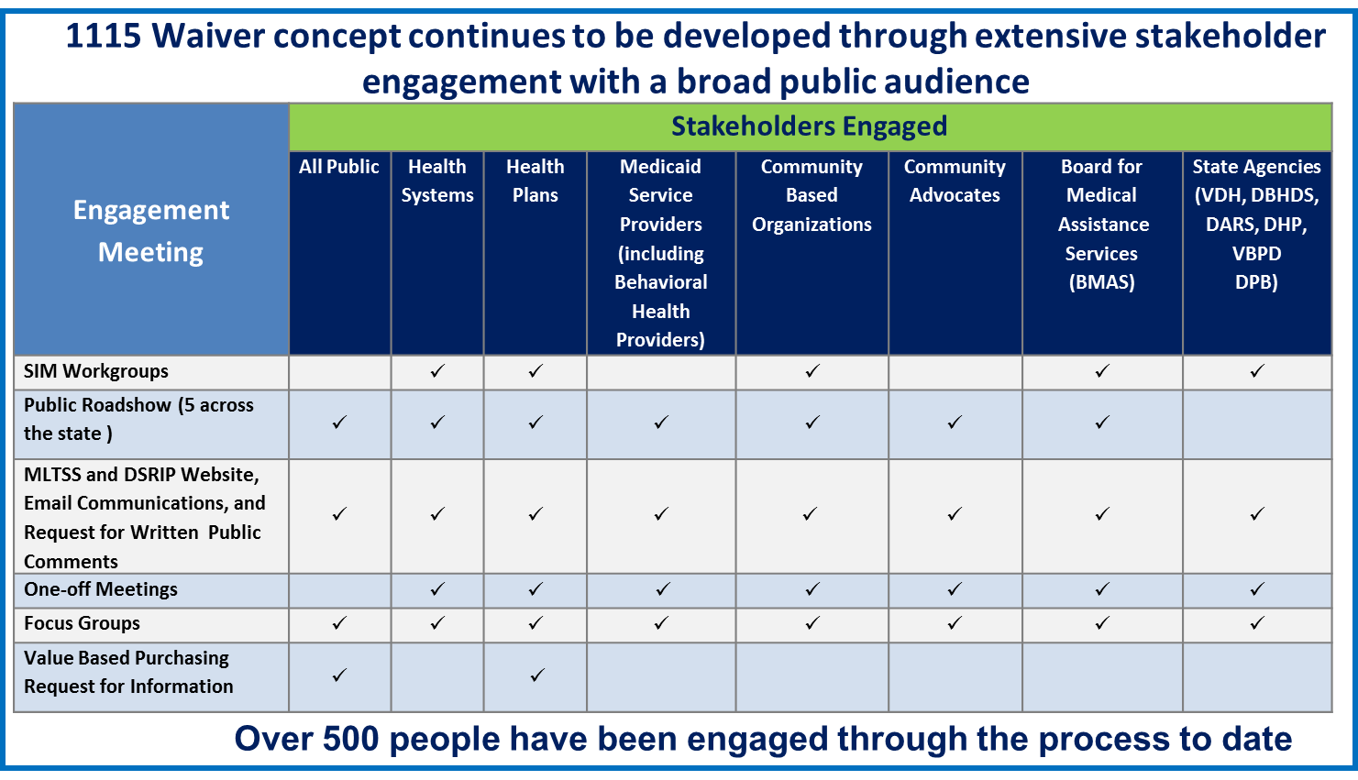

Individuals enrolled in the Intellectual Disability, Developmental Disability, and Day Support waivers will continue to receive their HCBS through Medicaid fee-for-service until the Department of Behavioral Health and Developmental Services completes the redesign of these waivers. Individuals residing in ICF-ID facilities will be excluded from MLTSS until after the completion of the redesign.
Ibid

