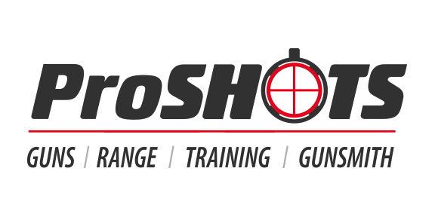
Join us for……
Free Seminars
Tuesdays this Summer, 7pm-8pm

June 7 – Home Defense Strategies
Instructor – Kyle James

June 14 – Defensive Use of Lethal Force Under State and Federal Law
Instructor – Richard Talbert

June 21 – Gun Cleaning
Instructor – Malcolm Maske

June 28 – Civilian Response to Active Shooter
Instructor – Joshua

July 5 – Church Security Planning for Active Shooter
Instructor – Kyle James

July 19 – Emergency First Aid for Gunshot Wounds
Instructor – Richard Talbert

July 26 – AR-15 Mods and Accessories
Instructor – Josh Wilson

August 2 – Paul’s 5 to Survive
Instructor – Paul Greve

August 9 – Less Than Lethal Defensive Implements
Instructor – Kyle James

August 16 – Knife Fight Basics
Instructor – Paul Greve

August 23 – How to Obtain Your First Firearm
Instructor – Richard Talbert

August 30 – Shotgun Basics
Instructor – Kyle James

Only 30 seats available per class, so sign up for free today!
Please register at www.proshots.training or call us at 336.969.4867

