Month | Carnegie Programs | Carnegie Program Attendees | Carnegie Door Count | Carnegie Computer Use | Carnegie Honor Book Use
Jul-14 | 50 | 1749 | 4556 | 820 | 1226
Aug-14 | 29 | 962 | 2865 | 713 | 849
Sep-14 | 38 | 1019 | 2863 | 655 | 1220
Oct-14 | 38 | 2505 | 4268 | 753 | 1103
Nov-14 | 35 | 805 | 2477 | 578 | 976
Dec-14 | 27 | 501 | 2172 | 571 | 829
Jan-15 | 31 | 719 | 2248 | 575 | 738
Feb-15 | 34 | 824 | 2311 | 534 | 961
Mar-15 | 40 | 1180 | 2826 | 507 | 930
Apr-15 | 34 | 847 | 2400 | 581 | 948
May-15 | 29 | 448 | 1875 | 505 | 940
Jun-15 | 41 | 1504 | 3281 | 605 | 1448
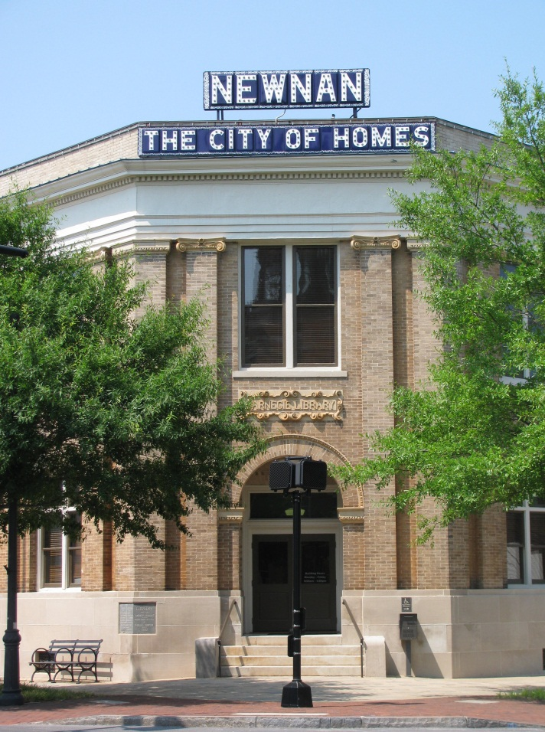
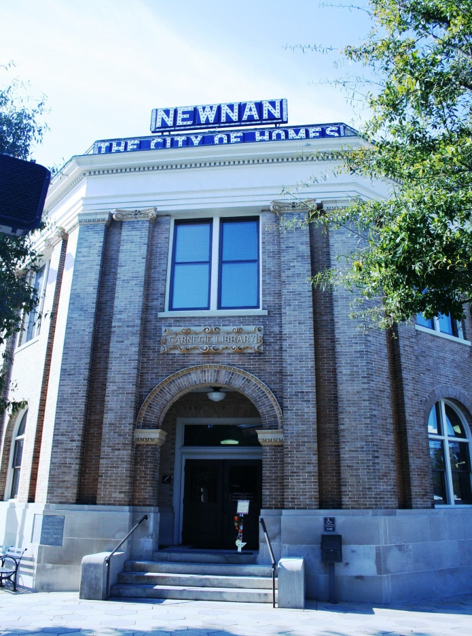
Carnegie Highlights:
- Community partnerships
  - Newnan Presbyterian Church
  - Leaf and Bean
  - Murphey’s Florist
  - Piedmont Newnan Wellness Center
  - Let Them Eat Toffee
  - Goodwill
  - The Coweta Shopper
  - Coweta Life
  - Something Special
- Special Georgia Cities Week program for children of all ages with many of our community partners
- Celebrated fifth anniversary of the Carnegie Literary Circle
- New owl painting in the Carnegie Kids Korner provider by art teacher Carol Toole from Newnan High School, painted by Emily Hinely
- Kicked off summer programming June 1 with many programs sponsored by the Newnan Carnegie Library Foundation
- Carnegie Crochet group donated blankets to Homestead Hospice

1 LaGrange Street, Newnan, Georgia 30263

