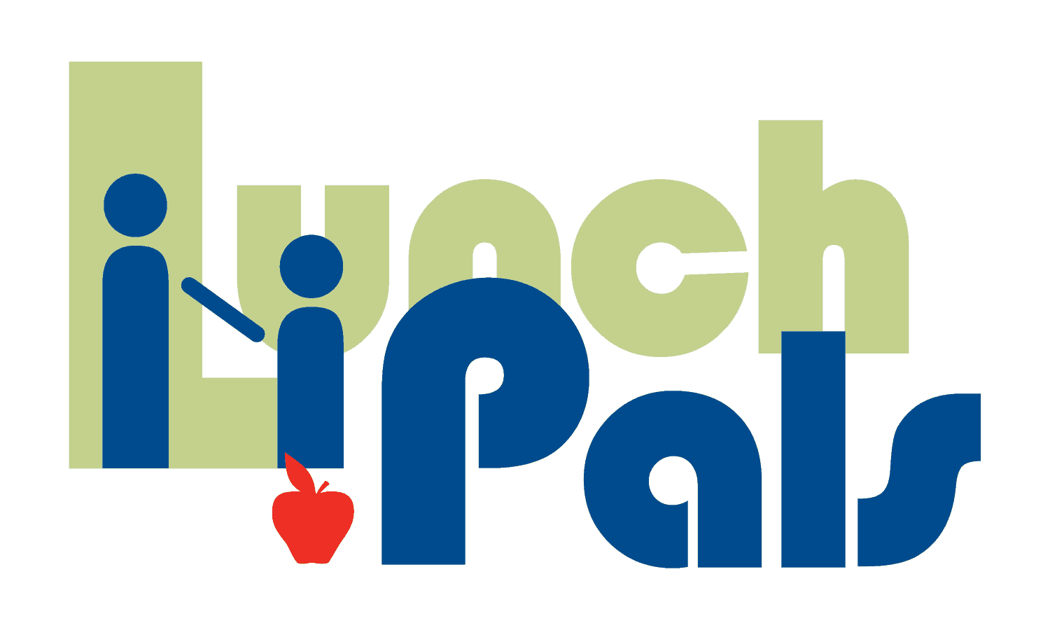

Kids and Careers at Raymond James

The hallways of Raymond James were buzzing with excitement as more than 90 students from Mt. Vernon and Lynch Elementary Schools arrived to visit their Lunch Pals mentors at work on May 16th. The smiles were endless as children spotted the faces of their mentors, and the joyful greetings showed how important the relationships are to both the students and staff involved.
Students ranging from K5 through 5th grade enjoyed the chance to learn about their mentors’ careers and co-workers, tour the offices, and get inspired by the art collection displayed throughout the building. As the pairs returned to the large conference room, they enjoyed socializing over a kid friendly lunch. Messages of inspiration and thanks were shared by Raymond James personnel, school staff, and student spokespersons. Mentors were presented with personalized key chains crafted by students as well as many enthusiastic handshakes, fist bumps and hugs before returning to school.
Thanks to Raymond James for providing this day of fun, career exploration and hands on learning to inspire the workforce of tomorrow!

