Case Center for Reducing Health Disparities

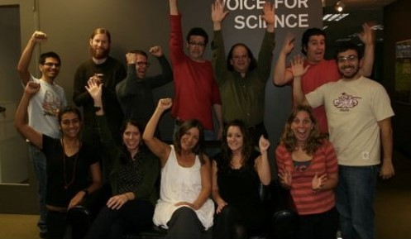

The First-Ever-Anywhere Done-In-A-Day Condom Access “Research Mob”

You’ve heard of Flash Mobs, and Cash Mobs. How about a Research Mob?

Recently we at the Case Center for Reducing Health Disparities heard of the idea of a Research Mob. The idea was only partially developed, but the concept was intriguing—it seemed that with a little refinement it could be a new way to engage people in research affecting their lives and communities. So we decided to try it out, to learn more about how it could work and test its potential for a range of research questions.

The idea is to take a pre-arranged question (below), and in the space of five hours, meet at a central site (MetroHealth), develop a good survey instrument, format it, print it, give copies to teams of people, have them fan out across the community, gather results, return to MetroHealth, tabulate and aggregate results, and distribute those results to an email list of key individuals for reflection and discussion. In five hours.

We wanted to select a question that has true public health meaning, and could lead to actionable change. There were a number of options, but the one we chose, because of the disparate burden of HIV, sexually transmitted infections, and unintended pregnancy, is access to latex condoms. Therefore, the question is:

Within key Cleveland neighborhoods, how accessible are latex condoms?

“Accessible” would mean available at stores and other sites in walking distance from fixed locations. So we’re recruiting participants for our first Done-In-A-Day Research Mob. Participants will receive a $25 Giant Eagle Gift card to help compensate for their time, a box lunch, and a place in history as one of the first Done-In-A-Day Research Mob scientists. Here are the particulars:

Date/Time: Saturday, November 7, 10:00am – 3:00pm (participants must commit to the entire time)
Location: SouthPointe Commons (right next to MetroHealth on West 25th)
Parking: Will be validated; park at the MetroHealth visitors lot
Attire: Comfortable, walking attire
Transport: While a car is not required, will we need cars to carry out the project
To sign up: Email Earl Pike at earlpike@yahoo.com. Space is limited to 36 people, so RSVP quickly!

Questions? Call or email Katrice Cain at kcain@metrohealth.org.

